Children’s Sermon
Loaves & Fishes Offering

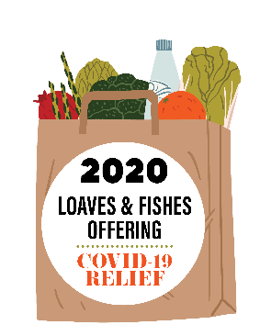

READ: The Lord upholds all who fall and lifts up all who are bowed down. The eyes of all look to you, and you give them their food at the proper time. You open your hand and satisfy the desires of every living thing.
Psalms 145:14-16 (NIV)

Have you ever wanted something so badly that you really, really beg and even pray that you will get it? But, unfortunately, everywhere, and anytime you ask, you are told, “No!” I promise you; this happens to all of us at some time or another.

But, I’m guessing for me to say that it happens to other people too doesn’t really make you feel any better, does it? So, what happens? Do you feel sad, disappointed, upset, angry? There are probably a lot of different feelings you have.

People who have heard the answer “No” a lot in their lives will have those same feelings–and it’s not just kids but adults too! Did you know that adults get told “No?” Well, they probably get told a lot more than you do. Hard to believe isn’t it?

The scripture I read talks about “all who fall.” Those are some fancy words for those who have heard “No” a lot in their lives. They get very discouraged and all they have left is to rely on God. The Psalmist is saying that God will lift up these people and say “Yes” to them.

God knows the perfect time to say “Yes” to a person who has been told “No” for a long time. In this scripture it talks about giving food at the right time.

Have you ever been so hungry, and you smell the food cooking in the kitchen, and you ask if it’s ready? And whoever is cooking tells you it is not quite ready. You walk away disappointed and feeling so hungry. And, just when you think you cannot stand it any longer, you hear, “Dinner is ready!”

That is kind of what is happening here. God will provide all things, including food, at just the right time. Our Loaves & Fishes Offering, which helps feed people, is happening at just the right time to respond and help the people of the Philippines and Guatemala as we respond, from God’s gifts, with a “Yes” to their needs.

