Feeding the Mind, Body, & Spirit
2019 Loaves & Fishes Offering
“He defends the cause of the fatherless and the widow, and loves the foreigner residing among you, giving them food and clothing.” Deuteronomy 10:18 (NIV)

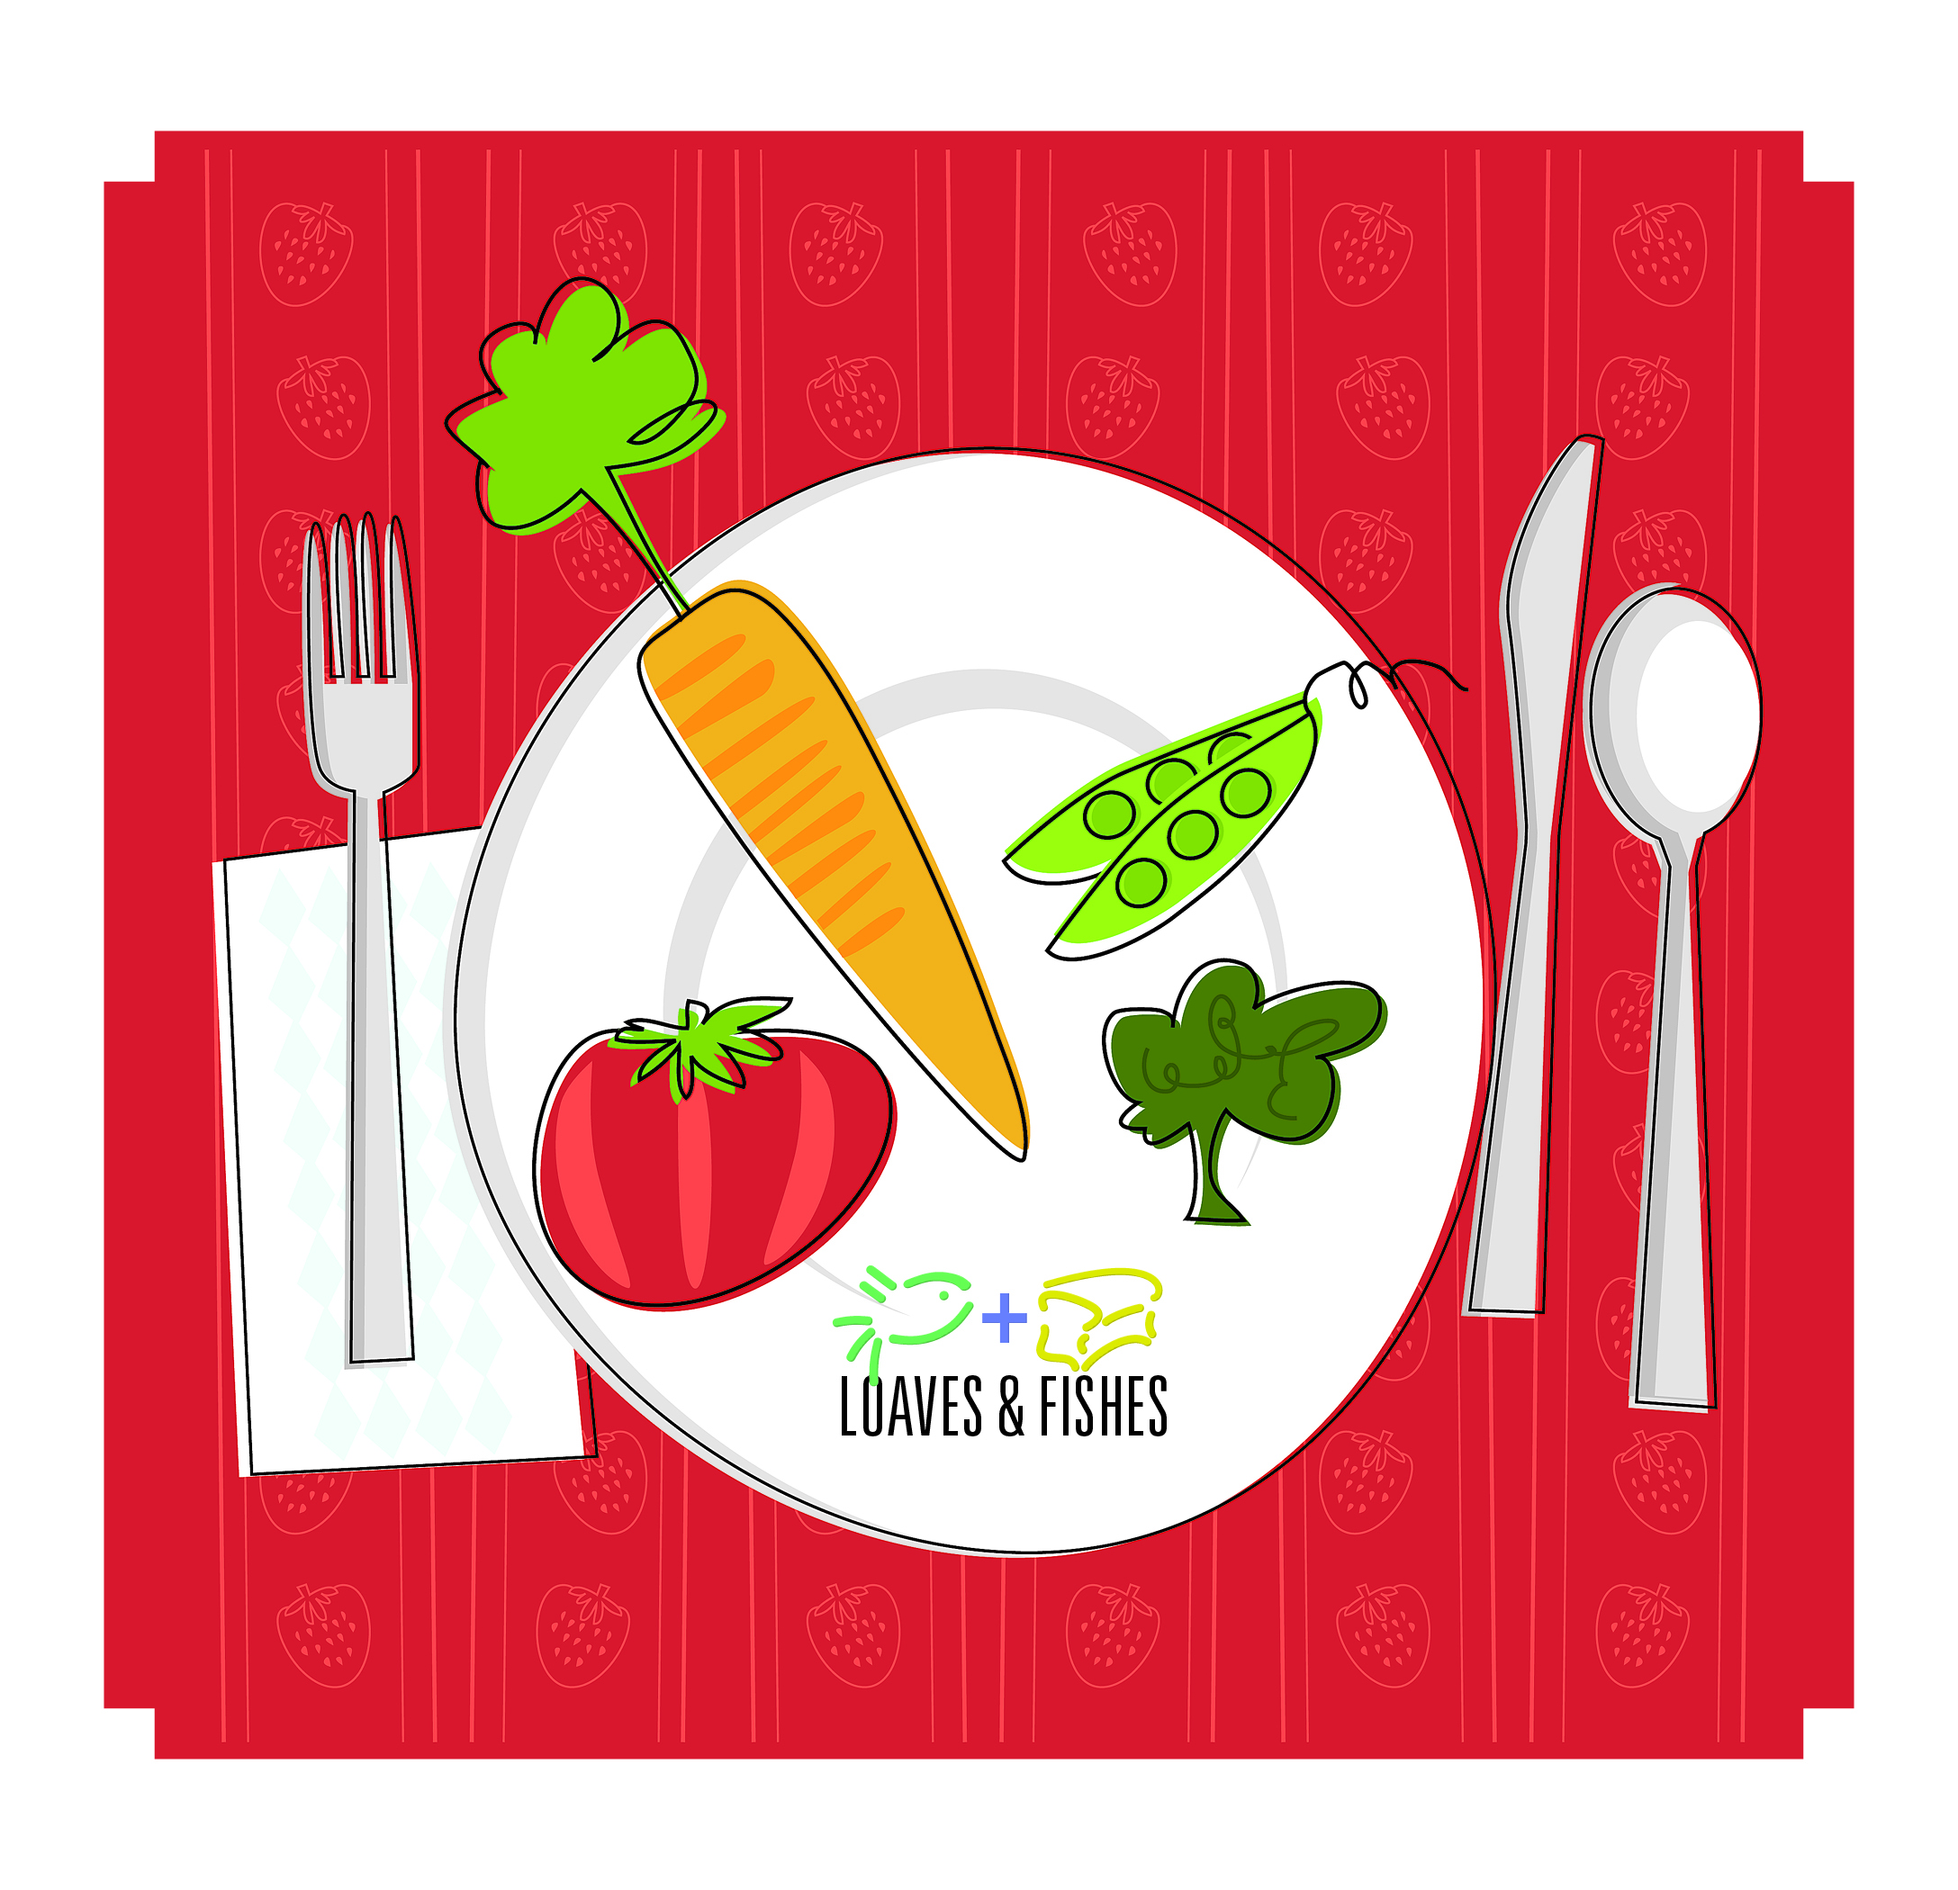
Throughout scripture God calls people to help others. Numerous scriptures call upon us to help our brothers and sisters by clothing the naked and feeding the hungry. This is not a simple request. It is a demand from God.
Just like those in the scriptures, our congregations and our greater church denomination are being called to feed the mind, body and soul of others. As those who have been blessed beyond measure, the Church has the opportunity to reach out to others, to extend the hand of holy hospitality and; with no expectation in return, share the love of Christ and the grace of God to those needing to be fed.
Experiencing hunger, whether it be physical, spiritual or emotional, can be a destitute situation. It is an epidemic throughout the world. We have children starving. We have people who don’t yet know God. We have those struggling with mental illness. People are hungry and desperate. There is an epidemic that needs to be addressed.
The Loaves & Fishes Offering is an avenue to address these issues. The funds given to the offering will help provide partnering organizations of the Cumberland Presbyterian Church to reach out into their communities (and beyond) to those who are desperate and full of despair and of hope and healing.
Project Vida, Coalition of Appalachian Ministries and Beth-El all have varying missions and touch different sectors of people, yet, still have the same goal – to provide resources to those who are in need. We, as people of God, are called to respond to the scriptures and help others in need. Funds given through the Loaves & Fishes Offering will be distributed equally among the three organizations to help “defend the cause of the fatherless and the widow, to love the foreigner residing among us, and give food and clothing.”
Thank you for your participation in the Loaves & Fishes effort this year!

Feeding the Mind, Body, & Spirit
2019 Loaves & Fishes Offering
“He defends the cause of the fatherless and the widow, and loves the foreigner residing among you, giving them food and clothing.” Deuteronomy 10:18 (NIV)

Throughout scripture God calls people to help others. Numerous scriptures call upon us to help our brothers and sisters by clothing the naked and feeding the hungry. This is not a simple request. It is a demand from God.
Just like those in the scriptures, our congregations and our greater church denomination are being called to feed the mind, body and soul of others. As those who have been blessed beyond measure, the Church has the opportunity to reach out to others, to extend the hand of holy hospitality and; with no expectation in return, share the love of Christ and the grace of God to those needing to be fed.
Experiencing hunger, whether it be physical, spiritual or emotional, can be a destitute situation. It is an epidemic throughout the world. We have children starving. We have people who don’t yet know God. We have those struggling with mental illness. People are hungry and desperate. There is an epidemic that needs to be addressed.
The Loaves & Fishes Offering is an avenue to address these issues. The funds given to the offering will help provide partnering organizations of the Cumberland Presbyterian Church to reach out into their communities (and beyond) to those who are desperate and full of despair and of hope and healing.
Project Vida, Coalition of Appalachian Ministries and Beth-El all have varying missions and touch different sectors of people, yet, still have the same goal – to provide resources to those who are in need. We, as people of God, are called to respond to the scriptures and help others in need. Funds given through the Loaves & Fishes Offering will be distributed equally among the three organizations to help “defend the cause of the fatherless and the widow, to love the foreigner residing among us, and give food and clothing.”
Thank you for your participation in the Loaves & Fishes effort this year!

