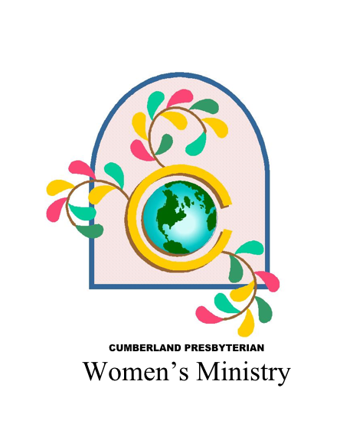

**2018 – 2019 Women’s Ministry Projects & Offerings**

**Stott-Wallace Missionary Fund**

Convention voted to for all local and regional women’s ministry group to collectively support the Stott-Wallace Missionary Fund in the FALL of each year. This fund goes to support the salaries and benefits of CP missionaries serving outside the United States. Women of the Cumberland Presbyterian Church have deep roots in supporting missionaries and the missionary effort. This collective project will once again unite women in supporting CP missionaries.

**Funding Goal:** Not Specified

*Make checks payable to Missions Ministry Team (8207 Traditional Place, Cordova, TN 38016) and designate for “CPWM Stott-Wallace Offering” - #34026).*

**Furniture for Missionaries**

We have a new missionary family, Reverends Wilson and Diana Lopez (and two daughters) that will be deployed to the mission field in late 2019 or early 2020. Their deployment date depends on deputation (fund raising) and visa approval by the countries they will work in as missionaries. Our missionaries go to the mission field with suitcases and are expected to buy furniture for their homes when they arrive. This project proposal is asking for $6,500 in donations to help the Lopez family buy basic furnishings, refrigerator, washer, dryer, beds, for their home in Spain on the mission field.

**Funding Goal:** $6,500

*Make checks payable to Missions Ministry Team (8207 Traditional Place, Cordova, TN 38016) and designate for “Furniture for Missionaries” - #34027).*

**2020 Convention Offering – Sacred Sparks Lunch and Laundry Program**

Sacred Sparks Ministry is a ministry of Nashville Presbytery that provides outreach and pastoral care to men and women experiencing homelessness and extreme poverty.

The ministry allows people of all ages an opportunity to serve and be in relationship with a community of people who they may have never before had the opportunity to know and serve.

As we have celebrated our 5year anniversary serving God’s people through this ministry, the weekly Laundry & Lunch program has become the largest focus of the ministry. The community served by Sacred Sparks has grown to rely on this weekly resource and time of fellowship.

* Weekly Budget for Laundry & Lunch program $350
  + laundry, laundry supplies, transportation, lunch/lunch supplies
* Weekly Budget for Day shelter $50
  + transportation, lunch/supplies

**Funding Goal:** Unlimited

*Make checks payable to Missions Ministry Team (8207 Traditional Place, Cordova, TN 38016) and designate for “Sacred Sparks” - #34051.*

**Other Opportunities to Give to Women’s Ministry**

**Membership Endowment Fund**

The Membership Endowment was established in 1924 by Mrs. Eva Hughs, of Missouri, a pioneer and courageous worker who had labored sacrificially for the cause of missions, and became concerned that her life would soon be spent and she would no longer be able to serve. As a result, working through the Board of Missions, she established the first of two Membership Endowments – The Perpetual Membership Endowment. Later the Patron Membership Endowment was established. For varying amounts of money, different memberships can be bestowed upon an individual (living or deceased). For more information on these endowments, contact the Women’s Ministry Office – 901.276.4572; cpwm@cumberland.org; or visit the Women’s Ministry website at cpcmc.org/mmt/cpwm.

**CP Women’s Ministry Bethel University Scholarship Endowment Fund**

This endowment was established in 1976, in honor of Beverly St. John for service given by her to Cumberland Presbyterian Women. A scholarship is to be awarded annually by Bethel University to a young woman going into full-time Christian ministry, the field of Christian education, the area of music ministry or other related fields. Convention voted in 2017, that if there is no CP woman planning to enter Christian ministry, then the scholarship can be awarded to any CP woman enrolled at Bethel University. The scholarship is in the amount of $2,000. All contributions should be mailed to the Missions Ministry Team, 8207 Traditional Place, Cordova, TN 38016.7414. ***Please make check payable to the Missions Ministry Team and designate it for the "CPWM Bethel University Scholarship Fund."***

**Women's Leadership Fund**

This endowment provides leadership development opportunities for women throughout the denomination. Workshops, retreats, seminars, and conferences on both regional and denominational levels help to achieve the goals of leadership development. Part of this endowment is held in trust, and only the earnings may be used. This will ensure leader development funds for current use as well as for future generations. All contributions should be mailed to the Missions Ministry Team, 8207 Traditional Place, Cordova, TN 38016.7414. ***Please make check payable to the Missions Ministry Team and designate it for the "Women's Leadership Fund"***

**Cornelia Swain Women's Ministry Endowment Fund**

This endowment was established in 1996 to fund much-needed financial resources for Women's Ministry. This fund was created to recognize the works of faith and the labor of love of Cornelia Swain, who served in Women's Ministry from May 1, 1977 until December 2002. All contributions should be mailed to the Missions Ministry Team, 8207 Traditional Place, Cordova, TN 38016.7414. ***Please make check payable to the Missions Ministry Team and designate it for the "Cornelia Swain Endowment Fund."***

