Missions Ministry Team
of the Cumberland Presbyterian Church
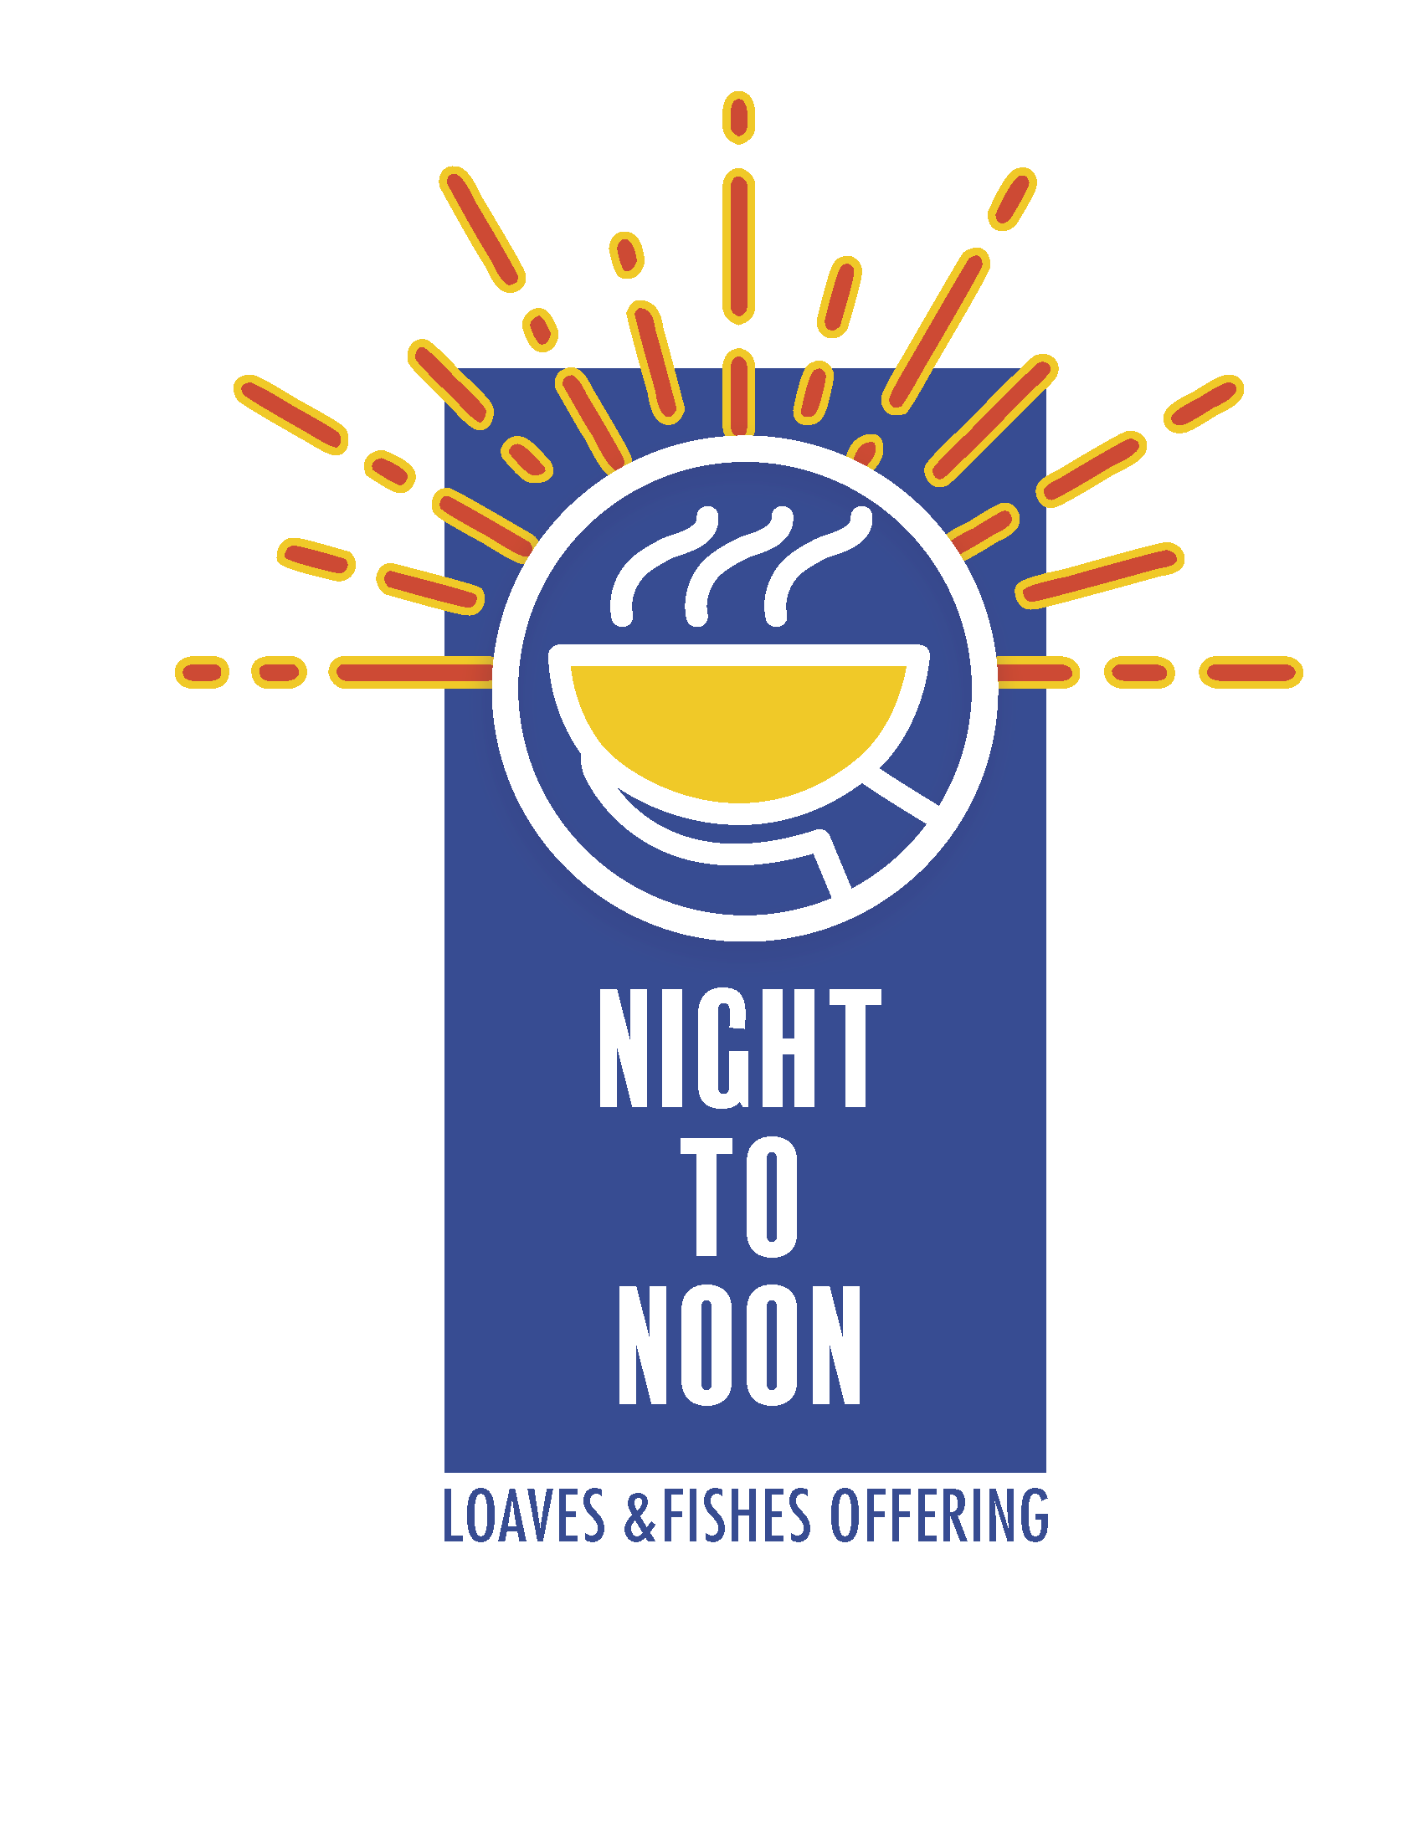
2018 LOAVES & FISHES AGREEMENT

We need _______ offering boxes (one per household)
We need _______ additional posters (The Missionary Messenger contains your poster.)
Worship resources are available on the website at: cpcmc.org/mmt/loaves/.

We plan to distribute the boxes on Sunday, November 4, and collect them on Sunday, November 18. We agree to distribute the Loaves & Fishes proceeds as follows: 75% to Philippine Child Development Program; 25% for local hunger programs.

Church ___________________________________________________________________________________
Address ___________________________________________________________________________________
City / State / Zip Code _______________________________________________________________________
I agree to responsibly carry out the Loaves & Fishes Program and to direct all funds into a hunger program.

____________________________________________________
Pastor’s Signature

Mail the boxes to:
Loaves & Fishes Coordinator _________________________________________________________________
Address ___________________________________________________________________________________
City / State / Zip Code _______________________________________________________________________

Note: This enrollment form should be returned to the Missions Ministry Team, 8207 Traditional Place, Cordova, TN 38016-7414.

