Night to Noon
2018 Loaves & Fishes Offering

"…and if you spend yourselves in behalf of the hungry and satisfy the needs of the oppressed, then your light will rise in the darkness, and your night will become like the noonday." Isaiah 58:10 (NIV)
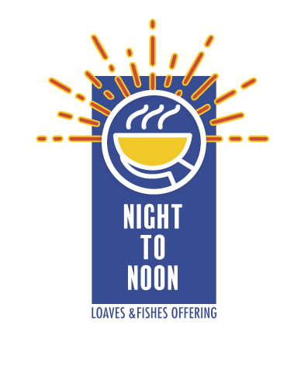
This year the Loaves & Fishes Offering will go to support the Child Development Program in the Philippines. This program is administered by the Council of CP Churches in the Philippines. Our missionaries, Daniel and Kay Jang provide strong administrative leadership for this program. There are various Child Development Programs in different CP churches/missions located on the island of Iloilo, Philippines. The program consists of a Saturday event where the children receive a hot meal, hear a Bible study, have classes on hygiene or some other relevant subject, sing and play games. The Loaves & Fishes Offering will be used to provide meals and supplies for the children that attend this program.
These children come from challenging circumstances. The program was developed by our missionaries years ago to help children from homes of modest resources. A nice hot lunch and an afternoon of fun activities for the children is like the dawn that sends rays of light to break the darkness. That was the hope of the Prophet Isaiah… that the darkness of hunger and oppression will turn to noon-day and they will be satisfied (Isaiah 58:10).
Please give generously this year to the Loaves & Fishes Offering on Thanksgiving Sunday, November 18. Please return the enclosed order form to obtain your Loaves & Fishes boxes or email your order form to jellis@cumberland.org. An order form and additional worship resources can be found on our website: cpcmc.org/mmt/loaves/. Thank you for your participation in the Loaves & Fishes effort this year!

Night to Noon
2018 Loaves & Fishes Offering

"…and if you spend yourselves in behalf of the hungry and satisfy the needs of the oppressed, then your light will rise in the darkness, and your night will become like the noonday." Isaiah 58:10 (NIV)
This year the Loaves & Fishes Offering will go to support the Child Development Program in the Philippines. This program is administered by the Council of CP Churches in the Philippines. Our missionaries, Daniel and Kay Jang provide strong administrative leadership for this program. There are various Child Development Programs in different CP churches/missions located on the island of Iloilo, Philippines. The program consists of a Saturday event where the children receive a hot meal, hear a Bible study, have classes on hygiene or some other relevant subject, sing and play games. The Loaves & Fishes Offering will be used to provide meals and supplies for the children that attend this program.
These children come from challenging circumstances. The program was developed by our missionaries years ago to help children from homes of modest resources. A nice hot lunch and an afternoon of fun activities for the children is like the dawn that sends rays of light to break the darkness. That was the hope of the Prophet Isaiah… that the darkness of hunger and oppression will turn to noon-day and they will be satisfied (Isaiah 58:10).
Please give generously this year to the Loaves & Fishes Offering on Thanksgiving Sunday, November 18. Please return the enclosed order form to obtain your Loaves & Fishes boxes or email your order form to jellis@cumberland.org. An order form and additional worship resources can be found on our website: cpcmc.org/mmt/loaves/. Thank you for your participation in the Loaves & Fishes effort this year!

