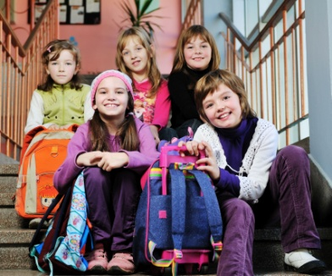
Celebrate!
Going Back to School
This Sunday is a great Sunday to think about kids since it is the Church’s time to celebrate going back to school and Christian Education. In fact, ‘tis the Christian Education Season. The Discipleship Ministry Team has many things going on in the area of Children and Family Ministry.
- Children’s Fest—an annual event held at Bethel University, McKenzie, TN, in July that welcomes children from all over the denomination to come together to learn, play, fellowship, worship and have fun with one another. (Ages K-6)
- Connect @ General Assembly—an annual event at General Assembly that focuses on kids who may be attending General Assembly with their parents or other family. Children ages K-6 grade get together daily for a few hours to learn about what is going on at General Assembly and have fun doing it.
Family Worship Space @ General Assembly—an area in GA worship for families with children to sit comfortably in worship together. It will be located where the children can see what is happening and where they have the ability to move around quietly during the worship service.

Consider giving a Tribute Gift to one of the above ministries in honor of one of your favorite kids. The Discipleship Ministry Team can send (if requested) a certificate to the child being honored. You may also want to give to the Jake Tyler Children’s Ministry Endowment to continue Children’s Ministry in the CPC for years to come. Go to https://cpcmc.org/discipleship/opportunities-to-give/ to give now.
Discipleship Ministry Team • 8207 Traditional Place •Cordova, TN 38016
Celebrate!
Going Back to School
This Sunday is a great Sunday to think about kids since it is the Church’s time to celebrate going back to school and Christian Education. In fact, ‘tis the Christian Education Season. The Discipleship Ministry Team has many things going on in the area of Children and Family Ministry.
- Children’s Fest—an annual event held at Bethel University, McKenzie, TN, in July that welcomes children from all over the denomination to come together to learn, play, fellowship, worship and have fun with one another. (Ages K-6)
- Connect @ General Assembly—an annual event at General Assembly that focuses on kids who may be attending General Assembly with their parents or other family. Children ages K-6 grade get together daily for a few hours to learn about “what is going on at General Assembly and have fun doing it.
Family Worship Space @ General Assembly—an area in GA worship for families with children to sit comfortably in worship together. It will be located where the children can see what is happening and where they have the ability to move around quietly during the worship service.

Consider giving a Tribute Gift to one of the above ministries in honor of one of your favorite kids. The Discipleship Ministry Team can send (if requested) a certificate to the child being honored. You may also want to give to the Jake Tyler Children’s Ministry Endowment to continue Children’s Ministry in the CPC for years to come. Go to https://cpcmc.org/discipleship/opportunities-to-give/ to give now.
Discipleship Ministry Team • 8207 Traditional Place •Cordova, TN 38016

