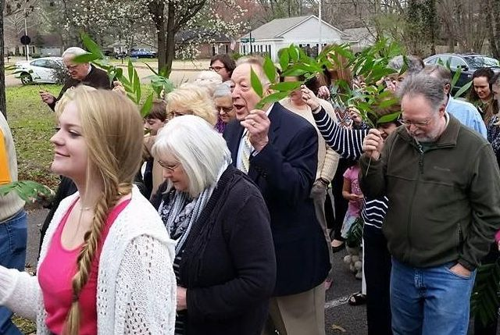
Celebrate!
A New Sunday School Year
Ring in the new year by celebrating our church teachers and leaders. They have the task of inspiring their students by sharing the good news. We celebrate because ‘tis the Christian Education Season. The Discipleship Ministry Team has resources to help Christian educators.
- Discipleship Blueprints—custom-designed leadership training for your congregation or presbytery. It is FREE (except for trainer travel expenses/lodging).
Here’s how it works:
You select a design.
You set a date.
Together we custom make a design for your group.
We come and train your group.
- Certificates—to honor or memorialize someone who has worked in the area of Christian education or who has been a loyal teacher for years. (5 certificate descriptions online)
Consider giving a Tribute Gift to one of the above ministries in honor of your Sunday school teachers or leader. The Discipleship Ministry Team can send (if requested) a certificate to the child being honored. You may also want to give to the CTE, Jodi Rush and Hubbard Endowments to continue Leader Development in the Cumberland Presbyterian Church for years to come. Go to https://cpcmc.org/discipleship/opportunities-to-give/ to give now.
Discipleship Ministry Team • 8207 Traditional Place •Cordova, TN 38016
Celebrate!
A New Sunday School Year
Ring in the new year by celebrating our church teachers and leaders. They have the task of inspiring their students by sharing the good news. We celebrate because ‘tis the Christian Education Season. The Discipleship Ministry Team has resources to help Christian educators.
- Discipleship Blueprints—custom-designed leadership training for your congregation or presbytery. It is FREE (except for trainer travel expenses/lodging).
Here’s how it works:
You select a design.
You set a date.
Together we custom make a design for your group.
We come and train your group.
- Certificates—to honor or memorialize someone who has worked in the area of Christian education or who has been a loyal teacher for years. (5 certificate descriptions online)
Consider giving a Tribute Gift to one of the above ministries in honor of your Sunday school teachers or leader. The Discipleship Ministry Team can send (if requested) a certificate to the child being honored. You may also want to give to the CTE, Jodi Rush and Hubbard Endowments to continue Leader Development in the Cumberland Presbyterian Church for years to come. Go to https://cpcmc.org/discipleship/opportunities-to-give/ to give now.
Discipleship Ministry Team • 8207 Traditional Place •Cordova, TN 38016

