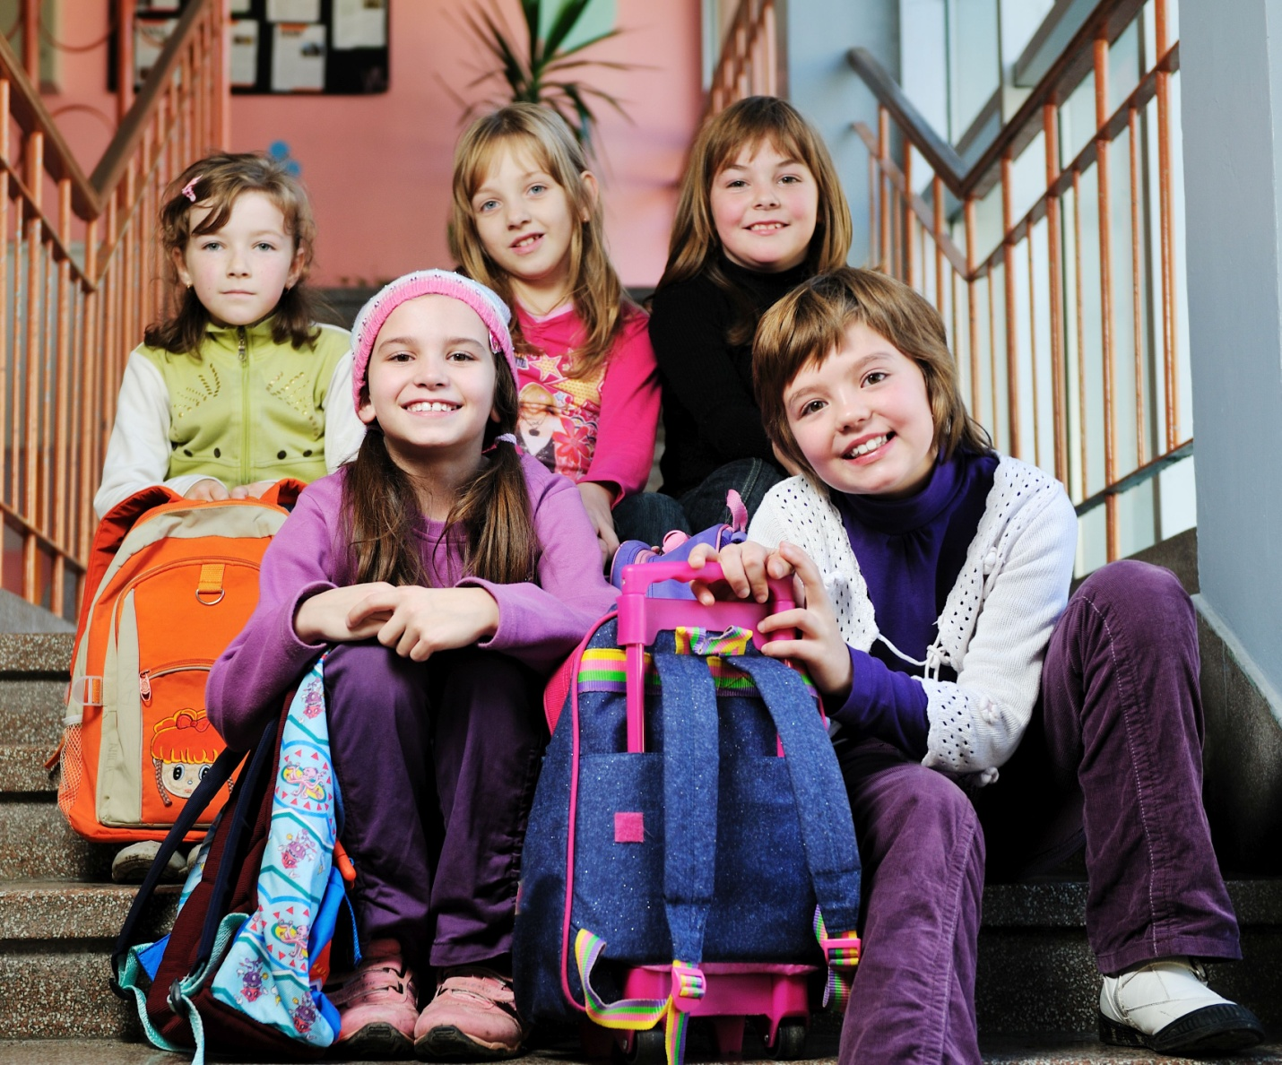
A Liturgy to Celebrate! Going Back to School
Week One of 2017 Christian Education Season
August 6, 2017
Elinor Brown
If your church doesn’t have children, please still plan to celebrate and pray for those going back to school (community kids, grandkids, family, etc.).
Preparation for the Sunday:
- Locate a copy of the song “Celebration” by Kool and the Gang to play as a gathering song for worship each Sunday of the CE Season. You may not want to play the entire song since it is about four minutes long and repeats.
- Ask your worship committee or a creative bunch of folks to decorate the worship area with Back to School items. You may want to decorate the altar or communion table with items such as a backpack, pens, paper, a soccer ball (or other sports balls), report cards, mascot(s) of area schools, lunchbox, etc. You may even want to use items that are from the “olden” days of school such as chalk and slate, an apple, a school bell, etc. You may want to roll in a white board that says Celebrate! Going Back to School.
- Well before this Sunday, ask some church children to draw pictures for visuals in the service. They may draw themselves and their schools, something that reminds them of Jesus, or some sort of celebration. Then transfer these to a slide presentation if you use one at your church or make posters at an office supply store and post them in around the sanctuary. Be sure the children put their names on the front of the picture so church members know who drew them. And make sure their art is seen and used as the gift that it is from the children.
- Look through the Additional Activities at the end of this liturgy and decide which of these you will do. Make plans to do them and gather materials as needed. You will also need to publicize and recruit people to help you with them so leave plenty of time to do so.
Call to Worship
Each line of this call to worship is to be a body prayer—a prayer acted out with motions. You may want to ask several children to lead this call and have them “rehearse” it with the congregation before the worship service begins. They may also want to lead the Prayer of Confession body prayer.
I asked the Lord for help,
(hold arms outstretched to heaven with hands folded in prayer)
and God saved me from all my fears.
(hands on hip, chest out)
Keep your eyes on the Lord!
(still hands on hips, look to the ceiling)
You will shine like the sun
(With fingers spread [jazz hands] move hands up over your head then slowly make an arc until they reach the sides of your body)
and never blush with shame.
(raise hands covering face palms out)
Come, my children,
(make beckoning motion with both hands)
Listen as I teach you to respect the Lord.
(hold right hand to right ear)
Do you want to live
(with elbows bent and palms up, move hands from center of body out to side)
and enjoy a long life?
(with elbows bent put right arm on left arm, then raise right arm keeping right elbow on left arm [signifying passing of time or sunrise])
Don’t say cruel things
(bring left hand to cover mouth)
and don’t tell lies.
(bring right hand to cover mouth and left hand)
Do good instead of evil
(bring hands to a prayer pose)
and try to live at peace.
(with hands still folded, bow head)
—Psalm 34:4-5, 11-14 (CEV)

Call to Confession
We all do things that are wrong and that we are sorry for. God is sorry about these things too. But God has told us through the Bible that if we pray and say we are sorry for doing these things wrong and really mean it, that God will forgive us and it will be like our lives have been washed really clean—as if we did not do anything wrong in the first place. That’s what it means to confess our sins. Let us do so now.

Prayer of Confession (unison)
I will sing to you, Lord!
(raise palms upward and raise arms with elbows slightly bent, look up to heaven)
I will celebrate your kindness
(raise hands and wave them back and forth)
and your justice.
(lower elbows to your side with palms facing up like justice scales)
Please help me learn to do the right thing,
(fold hands in prayer and bow head twice)
and I will be honest
(cross hands over your chest)
and fair.
(lower elbows to your side with palms facing up like justice scales)
I refuse to be corrupt
(hold up hands palms out and to the right, with head looking down and to the left)
or to take part in anything crooked,
(hold up hands palms out and to the left, with head looking down and to the right)
and I won’t be dishonest
(hands palms facing out at chest level, then push them down and back like you are pushing away sin)
or deceitful.
(turn head down and to the left)
Anyone who spreads gossip
(cup hands like you are silently shouting)
will be silenced,
(cross hands over your mouth)
and no one who is conceited
(cross arms over chest)
will be my friend.
(shake head)
I will sing to you, Lord!
(raise palms upward and raise arms with elbows slightly bent, look up to heaven)
I will celebrate your kindness
(raise hands and wave them back and forth)
and your justice.
(lower elbows to your side with palms facing up like justice scales)
Please help me learn to do the right thing,
(fold hands in prayer and bow head twice)
and I will be honest
(cross hands over your chest)
and fair.
(lower elbows to your side with palms facing up like justice scales)
—Psalm 101:1-5 (CEV)

Assurance of Pardon
God has given us really great news! If we confess our sins, we are forgiven and we are washed clean. And that is what we just did! So we need to believe this great news and we need to live our lives like Jesus lived his life—with kindness and love. Thank you God.

Children’s Message
Read the book Stand Tall, Molly Lou Melon by Patty Lovell. If you do not own this book, this is a great opportunity to buy it for yourself or for your church’s nursery or library. After reading it, you may want to make the following points:
- Today the scripture is talking about being ready when the master comes.
- Molly Lou’s grandmother helped her get ready for life by giving her good advice: Walk as proudly as you can and the world will look up to you; Smile big and the world will smile right alongside you; Sing out clear and strong and the world will cry tears of joy; Believe in yourself and the world will believe in you too.
- Molly found out that her grandmother’s advice helped her a lot when she went to her new school and faced a boy that was not really all that nice. But she was ready and showed everyone what a great person she was and the great gifts she had to offer others.
- We can all be ready in that same way: ready for school, ready to share about Jesus, and ready to share love that God and Jesus shared with us, with others.
- Then pray something like this: God, we know that life does not always go the way that we would like. There are going to be people like Ronald Durkin in our lives that want to be mean to us or embarrass us. Help us to believe in ourselves and be ready to show your love with them. Amen.

Prayer for Illumination
God, we know that your word in the Bible is called a light for us to know how to live and where to go. We ask that you would light up the words in scripture that are going to be read so we will understand them and be led by them so we will know the right thing to do in our life. Amen.

Scripture Possibilities for the Sermon
- Luke 12:32-40—Be ready with your lamps lit when the master comes.
This scripture is an opportunity for the pastor to talk to the children directly in this sermon. He or she might talk about how important it is to be ready: ready for school, ready to tell Jesus’ story or other people, or ready for other things that children might relate to.
This day is also a time to step out of the normal rituals of the worship service. Your church might ask the children to sit together in an area of the church and the pastor might come to speak in front of them rather than behind the pulpit. Be sure to take advantage of this time.

Prayers of the People
Introduce the church to the Hand Prayer. Explain to everyone that we are going to pray using our hands. As they point to each finger, invite them, as in a bidding prayer, to pray silently about the things that you ask them to. You may begin and end the prayer as you like.

Begin with the Thumb: Since it is the strong stronger finger, ask the congregation to pray and thank God for all of the strong things in their lives: home, family, and friends

Then the Pointer finger: Ask the congregation to pray for people to lead the way for us and help us: friends, teachers, doctors, nurses, pastors

Then the Middle finger: Since this is the tallest finger, ask the congregation to pray for people who have power—government leaders like presidents, prime ministers, governors, mayors

Then the Ring Finger: Since this is the weakest finger, ask the congregation to pray for people who are poor, weak, helpless, hungry, ill or sad.

Then the Pinkie Finger: Since this is the smallest and last finger, ask the congregation to pray for themselves.
—adapted from Dwelling: Helping Kinds Find a Place in God’s Story by Jessie Schut

Invitation to the Offering
We believe that God has given us everything. Everything is really God’s. So why do we give an offering? Because it is our way of saying: “God we know you give us everything that we need to live. We also know that some people don’t have what they need to life. So we want to help them out by giving some of our money, our time and our gifts back to you to help them out.” By doing this, we are acting like Jesus. And that is a very good way to act. Let’s give our offering to God.

If you intend to do a blessing of the backpacks, you may want to do it here.

Prayer of Thanksgiving
O God, you have given us so much. Give us one thing more—a grateful heart. Amen.

Charge and Benediction
Go out into the world to Celebrate! Celebrate life!
Celebrate going back to school to learn all that we need to know!
Celebrate other people and learn to live with them in peace!
As you celebrate know that God is there to protect you,
Jesus Christ is there to love you,
And the Holy Spirit is there to guide you. Go in peace!

Additional Activities
- Blessing of the Backpacks—Kathy Dawson, on her hope4ce website has a fantastic article about going Back to School resources (http://worshipingwithchildren.blogspot.com/2011/06/back-to-school.html) There are at least three sources she shares for backpack blessing resources. She also includes litanies and other prayers that you may want to include in this worship service or pass onto your congregation. Also available is a milestone rock from Milestone Ministry, http://www.buildfaith.org/2014/06/11/new-formation-resource-connects-church-and-home-milestones-ministry-manual/.
- Service Project: School Supplies—As a congregation, plan to collect school supplies to donate to a local mission that does this regularly. If you collect these supplies in June and July, you may want to bless these at this service. Bring them up at the time of the offering and do so then. Try to get a list of supplies needed by kids of all ages at your local school(s). These may include supplies such as Kleenex boxes, etc.
- Individual Service—Begin a tutoring and/or listening partner program at your church. Your outreach ministry might plan to take this project on. Allow church members to use their gifts to tutor kids either inside or outside the doors of the church. Or someone may want to be a listening partner for a child where their sole responsibility is to allow the child to read to them. With either of these possibilities, the greatest gift is time.
- Super Saturday—Plan a day that would allow children to come to your church for booster shots, sports check-ups, school supplies and whatever else they might make available to families who need help getting ready for school. This would be a huge undertaking, but you might join with several churches in the community to make something so important like this happen.

