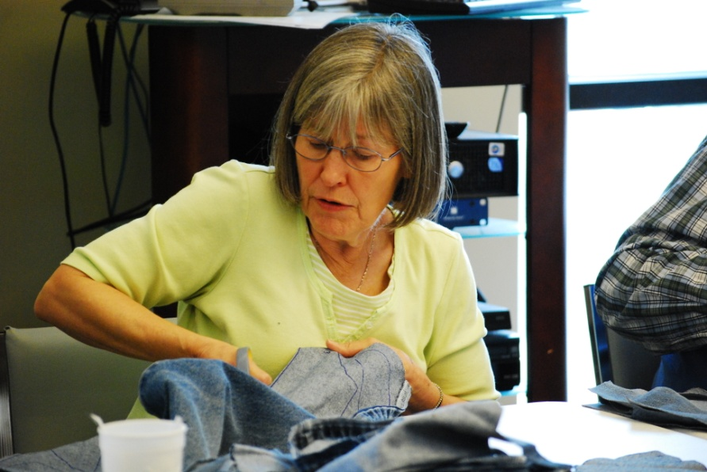
A Liturgy to Celebrate! Being of Christian Service
Week Seven of 2016 Christian Education Season
September 17, 2017
Victor Hassell (extras-Elinor Brown)
Preparation for the Sunday:
- Locate a copy of the song “Celebration” by Kool and the Gang to play as a gathering song for worship each Sunday of the CE Season. You may not want to play the entire song since it is about four minutes long and repeats.
- Ask your worship committee or a creative bunch of folks to decorate the worship area with items that represent service. You may want to pile your altar high with canned goods from your food bank, prayer shawls from your prayer shawl ministry, blankets for a homeless shelter, etc. Also create a triptych collage by covering 3 pieces of poster board with pictures taken on various mission trips or pictures from our mission fields (For more information, ask a Mission Ministry Team staff member). Enlarge pictures on regular paper so people in the congregation can see them. Then create three stencils: one reading “Act Justly,” one reading “Love Mercy,” and one reading “Walk Humbly.” Using the stencil, spray paint these words on the collages. If you can’t make a stencil, have someone write these words clearly on each collage. Arrange them in the order above so they read as Micah intended! (Idea adapted from the book Come and See by Dean R. Heetderks, p.36).
- Look through the Additional Activities at the end of this liturgy and decide which of them you will do. Make plans to do them and gather materials as needed. You will also need to publicize and recruit people to help you with them so leave plenty of time to do so.
Gathering Words from Isaiah 52:7-10
How beautiful upon the mountains are the feet of the messenger who announces peace, who brings good news, who announces salvation, who says to Zion, “Your God reigns.” Listen! Your sentinels lift up their voices, together they sing for joy; for in plain sight they see the return of the Lord to Zion. Break forth together into singing, you ruins of Jerusalem; for the Lord has comforted his people, he has redeemed Jerusalem. The Lord has bared his holy arm before the eyes of all the nations; and all the ends of the earth shall see the salvation of our God.”
(Isaiah 52:7-10 NRSV)

Song of Praise—Days of Elijah

Call to Worship
Listen… do you hear God’s mercy?
Creeping into the lives of folks who know heartache and despair.
Listen… do you hear God’s grace?
Whispering words of God’s unconditional love through Sunday school teachers
and van drivers—through folks providing a listening ear
and their undivided attention.
Listen… do you hear God’s forgiveness?
Reconciling and healing through truth-telling and meal-sharing,
loving and embracing.
Listen… do you hear God’ peace?
Providing a meal for those who worry they cannot,
providing a safe place to escape the hell folks are living in.
Listen… do you hear God?

Invocation
God of unconditional love, give us ears to hear the countless ways you reach out to us with mercy, grace, and forgiveness. Help us to listen for the countless ways you uphold us in times of sorrow and despair. Open our eyes to the beauty of your forgiveness reaching out to us when we think we are unforgivable. Help us see your face in the lives of the folks you have placed in our paths. And, help us to embrace the peace that you are constantly offering us with the gift of your Holy presence—through the one who has come, is coming, and will come again. Amen.
Hymn—Open My Eyes, That I May See

Prayer of Confession
O God, we confess that there are times when we are not mindful of your presence. When you are hungry, we do not feed you. When you are thirsty, we give you nothing to drink. When you are sick, we do not care for you. When you are in prison, we do not visit.
Please forgive us, and open our hearts and our minds and our spirits to your holy presence—that we may be willing to do what is holy and what is right. Amen.
Silent Prayers of Confession

Assurance of Pardon
(While pouring water into the baptismal font say…)
Listen… and feel God’s cleansing presence reaching out with forgiveness and love—promising that whatever is broken in our lives can be restored. Know and live in the blessing of God’s forgiveness. Amen.

Children’s Message
Read the book A Rose for Abby by Donna Guthrie. If you do not own this book, this is a great opportunity to buy it for yourself or for your church’s nursery or library. After reading it, you may want to make the following points:
- Today we are talking about people who see things that need to be done and then do them even if they have to leave their home to do so. Sometimes they only need to look out their windows to see what needs to be done. Doing things for others is called service; we are celebrating Christians who serve others because they love God.
- In this story, Abby looks out the window of her home which was next door to the church since her dad was the preacher. She saw a poor woman who was looking through the trash cans trying to find stuff she needed. Abby wanted to help her but didn’t know how, so she asked her dad if the church could help. Her dad said that the church was poor too. But that answer didn’t stop Abby from thinking.
- She thought about the lost and found box that had some gloves in it, so she took a paper bag, drew a rose on it, put the gloves in it, and then put the bag in the trashcan for the woman to find. And the woman did find it and was happy about the gloves because it was cold. Abby did this everyday with something different from the lost and found box. She also told her father that she knew the neighbors also had something to give. So they went to the neighbors to collect day old food, bowls and even found someone to cook soup for the street people. After the neighbors and the church served the crowd, Abby found a red paper rose placed in one the bags she had given the woman.
- Abby, a little girl, had a heart for service: which means that she felt the need to do good things for others. She shows us that we can all do something for other people to help them. And in the process, we are being a good example to other people, helping them to want to serve others too, which is what God wants us to do.
- Then pray something like this: God, we thank you for people like Abby who show us how important it is to serve others. Thank you for the people in the world who serve others and for the people in this church who serve others. Help us to be like them and like Jesus. Amen.
Hymn—Open Our Eyes, Lord

Prayer for Illumination
Lord, we seek to be transformed by your word. May your Holy Spirit guide us in the truth of your love and power. Open our ears, to hear your voice, our minds to understand your will and our hearts to trust in your love, so that we may serve you by serving others. We pray in Jesus’ name, Amen.
Scripture Possibilities for the Sermon
- Isaiah 52:6-10
- Matthew 25:31-46
- Luke 4:14-21

Testimonies of Faithful Service
For the sermon, ask three individuals to give testimonies of how God has used a specific ministry (Soup kitchen, VBS, warming shelter, Room in the Inn, mission trip, etc.) to help draw them closer to God. Ask them to be very specific—using examples of where they have seen God working through such ministries.
Prayers of the People
Hear, O Lord, the cries of your people. Be gracious to us and answer us as we lift up the concerns of our hearts…

You are invited to voice your prayers at this time and we will respond.
Lord, in your mercy,
Hear our prayers!

O God, we give you thanks for the many blessings of this life
and for the gift of heaven which is ours even now.
We give you thanks for those who have helped draw us closer to you.
Thank you for the servants you have used to reach out, love on, and care for us.

We ask that you would just be with us now—
as we try to live out the calling you have place on our lives—
so that we may bear witness to your abiding compassion for all who suffer.

We give you the glory now and always, God in Community,
even as we pray as we are taught, saying,
Our Father, who art in heaven, hallowed be thy Name.
Thy kingdom come; thy will be done, on earth as it is in heaven.
Give us this day our daily bread.
And forgive us our debts, as we forgive our debtors.
And lead us not into temptation, but deliver us from evil.
For thine is the kingdom, and the power, and the glory, forever. Amen.

If you intend to commission some of your service activities, you may want to do it here.

Invitation to the Offering
“How beautiful upon the mountains are the feet of the messenger who announces peace, who brings good news, who announces salvation…” Let us give so that all the ends of the earth might see the salvation of our God.
Prayer of Thanksgiving
We give you thanks, O God, for this opportunity to give and for the many gifts that have been given. We ask that you would take, bless, and use these gifts to make your presence known so that all may experience your salvation. Amen.

Charge and Benediction
Go now, and be who Christ has called and created you to be—
Go and feed and give and visit and care and serve—
Go and be blessed—
For surely whatever you do to the least of these is a blessing to all—including yourself.
And the blessing which you have received from God the Creator,
Redeemer, and Sustainer be with you always. Amen.

Additional Activities
Hope for the World Prayer Wall—Put a blue plastic table cloth on the wall in your church (long-wise horizontal). Then use a projector and a transparency of a flat map to draw a map onto the table cloth. Ask people to use the sticky notes and pens provided to write a note of hope for particular parts of the world (a country or region) and put the prayer on that area of the map. Leave this prayer wall up for several weeks to give people a chance to read the prayers and offer their own prayers for both the writer and the situation.
Leave a Piece of Your Church—Have a group from your church gather to discuss having something for mission workers from your church to give to someone on the mission field. It may be a coffee cup with your church’s logo on it or a handcrafted item that one of your members has made. Consider its size and weight, which is usually an issue when packing for a trip. Have the church member giving the gift to take a picture with the recipient and post it somewhere special at the church.
Commission Your Servants—Have the pastor set up a regular time in a worship service to commission those who are going to be working in Christian service. These people may include those who work regularly in a soup kitchen, a homeless shelter, a mission trip, as a volunteer at a local hospital, a teacher, etc. Broaden the church’s idea of what it means to be a Christian servant. You might be surprised at those who are serving and those who would like to serve given the chance.

