Stott-Wallace MISSIONARY

OFFERING
On the Day of Pentecost people of different languages and cultures came together to worship God leading to the birth of the Church. The Church was then tasked to send missionaries into the world to proclaim the Kingdom of God. Those missionaries had to eat, find housing, and buy clothes. These first missionaries learned to live off the leftovers (Phil. 4:15, 2 Cor. 11:9) as did the Old Testament heroine Ruth.
On December 29, 2016 the new missionaries Rev. Jacob and Lindsey Sims and their three children flew to Brazil as new CP missionaries.
In mid-2017 the goal is that Rev. Patrick and Jessica Wilkerson and their two small children will move to Colombia as new missionaries. We as a Church continue what Pentecost started. We send missionaries into the world because God so loves the world. Commissioning new missionaries is both exciting and challenging. It is exciting with the prospect of growing the Kingdom of God in new lands and also challenging as we face the reality of living off the leftovers. The world needs missionaries willing to sacrifice the known world, family proximity, and security for something vitally important. As Paul writes in Romans 10, “how can they believe in the one of whom they have not heard? And how can they hear without someone preaching to them?”
In 2017 it will take almost $400,000 a year to cover missionary expenses, salaries and benefits to support all of our CP missionaries. Missions is a part of the Church that lives off church offerings, it is the widow that goes into the wheat field after it has been harvested gleaning the leftovers. If only 200 persons, church or groups (Sunday school classes) gave $2,000 a year that would be enough for our current missionary staff.
Pentecost Sunday is June 4, 2017, which is also World Missions Day. Cumberland Presbyterians celebrate and receive the Stott-Wallace Missionary Offering, which helps support all endorsed CP missionaries. Checks should be made payable to the Missions Ministry Team, 8207 Traditional Place, Cordova, TN 38016. You may also visit the Stott-Wallace Missionary Offering website to make a pledge or a contribution cpcmc.org/mmt/sw. Resources including the new video are also provided on this website.

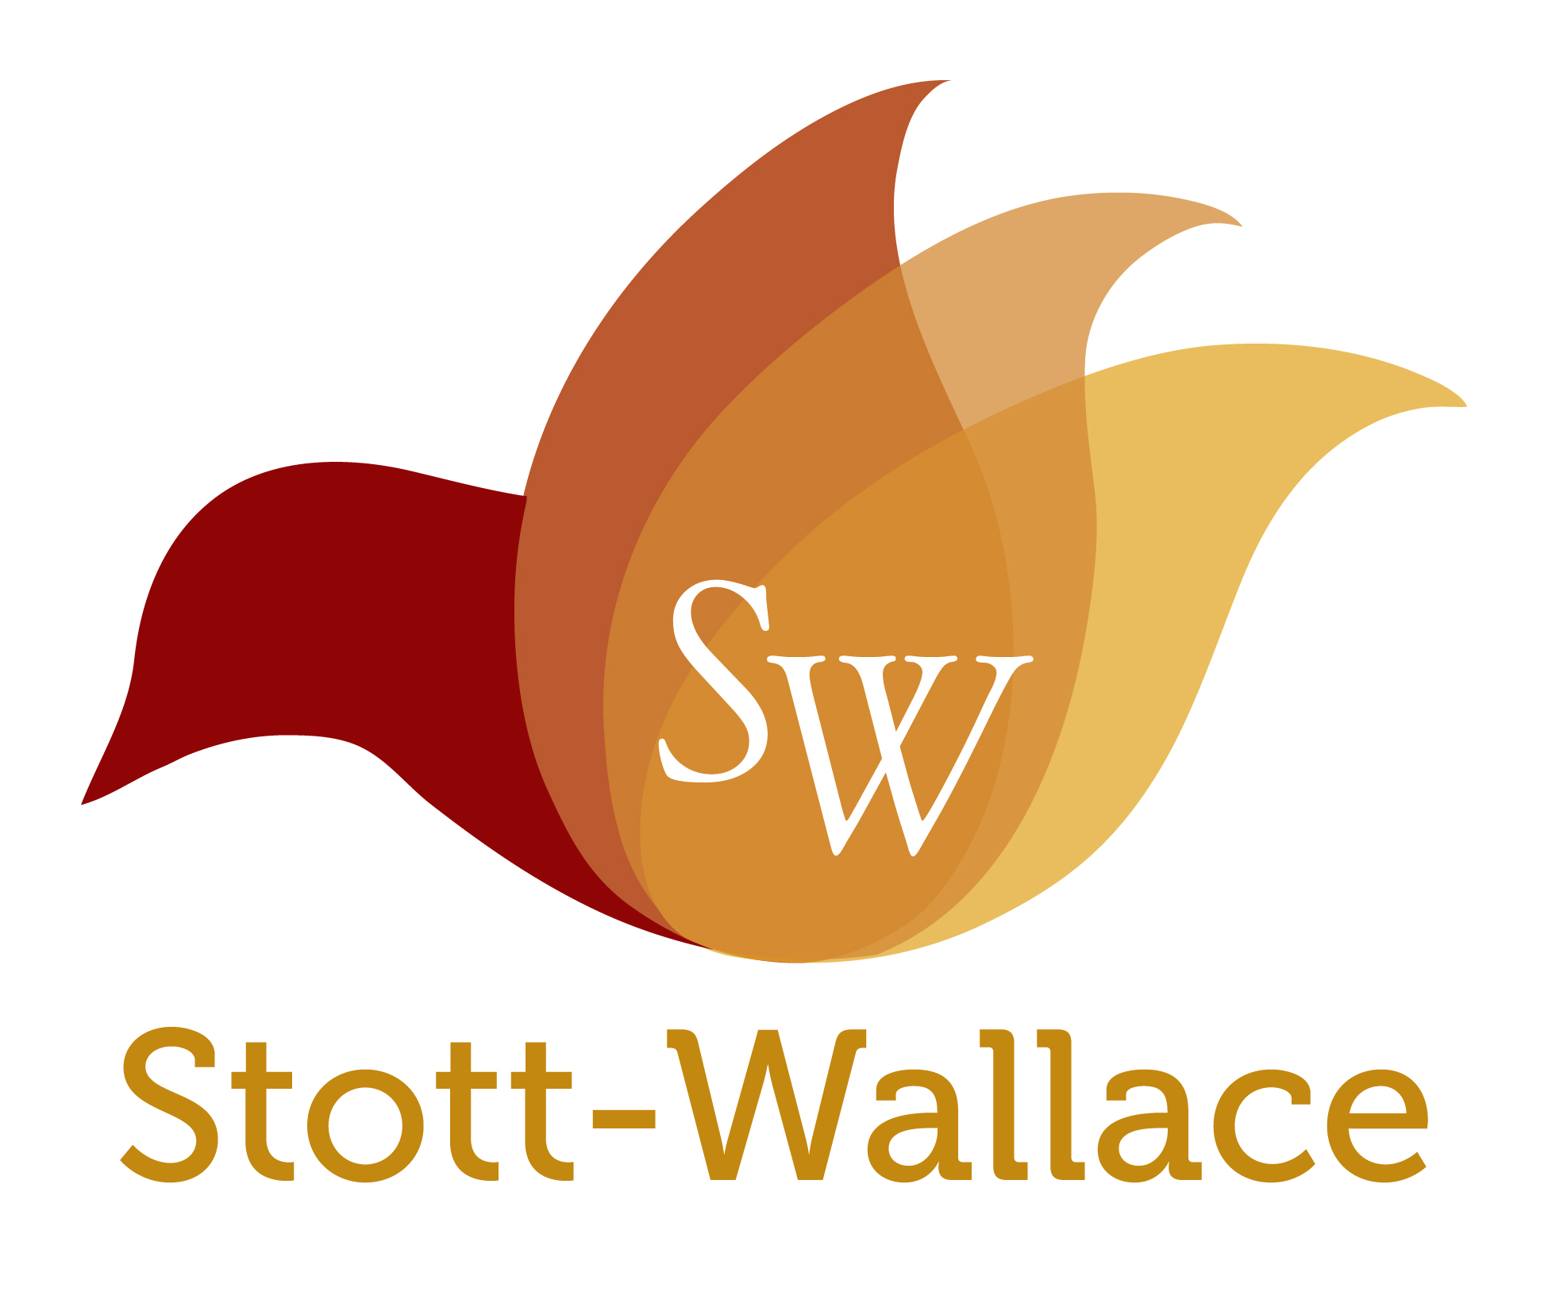

The Stott-Wallace Missionary Offering Fund was established in 2012 by the General Assembly and CP Women’s Ministry to fund the salary and benefits of Cumberland Presbyterian missionaries. It is named in honor to two lifelong missionary families. Boyce and Beth Wallace and Buddy and Beverly Stott. The Wallaces served in Colombia, South America for over 50 years in church planting and leadership development. Rev. Wallace passed away this past January. The Stotts served in Japan for 26 years. Buddy died in 2005. Beth Wallace continues to make her home in Colombia. Beverly has recently moved to live with family in North Carolina. The Church is eternally grateful to these missionary families who sacrificed much to serve God.

