A Liturgy for Pentecost/Mission Sunday
Formal/Traditional Version
June 4, 2017

As God said: “I will live with them and walk among them, and I will be their God, and they will be my people.” II Corinthians 6:16

Call to Worship:
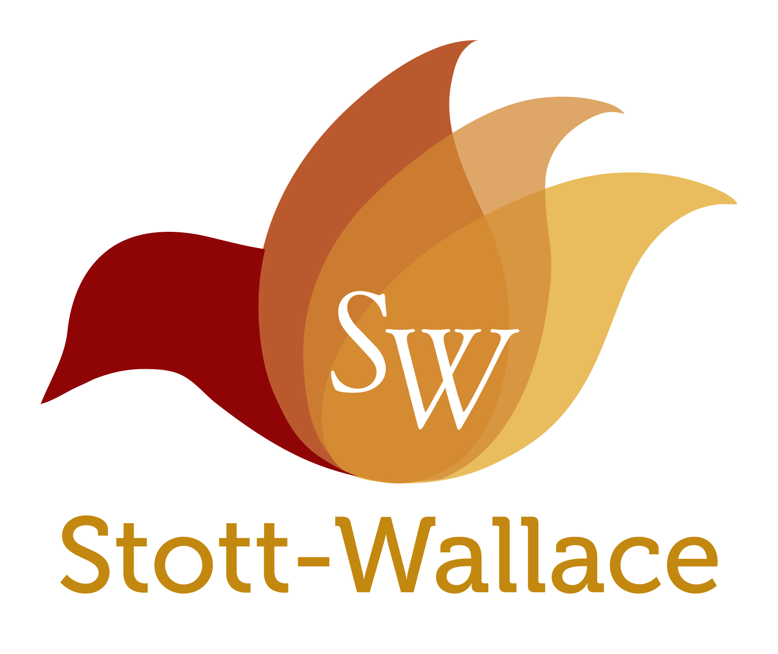
By the Spirit, the church is gathered.
The church is gathered to plead, “Come, Lord Jesus, Come.”
By the Spirit, we are built up in comfort and teaching.
The Spirit reminds us of all that Jesus taught us.
By the Spirit, we are sent out.
We are sent out to every nation and every tribe.
We are sent out to proclaim that we are God’s people.

God walks with us, and we are His people.

Unison Prayer of Confession:

Lord, we confess that we are scared of you, the Holy Spirit. We are scared of the ways you will disrupt our lives and call us to do something new. We confess that when your Spirit speaks, we turn deaf ears. When your Spirit touches our lips, we close our mouths, embarrassed to speak Your Word. Give us courage, and forgive us, Lord. In Jesus’ name we pray, Amen.

Assurance of Pardon:

God promises to walk among us. God promises to be our God. If God is with us, who can be against us? Take heart and take courage: in the name of Jesus Christ you are forgiven. Take heart and take courage for God promises to walk among us.

Prayer of Dedication for Stott-Wallace Missionary Offering:

Holy Spirit, we offer our gifts to reach beyond our small worlds. We offer our gifts and remember all of the amazing work you are doing in the Cumberland Presbyterian Church. We are one family, united in you. We speak different languages and celebrate different holidays. We eat different foods and have different traditions. But, in your church, we are one. Multiple the gifts we give that all your children might be blessed through the work of our hands. In the name of the Father, and the Son, and the Holy Spirit, we pray. Amen.

Scripture Suggestions for Sermon:

- Acts 2:1-21
- Numbers 11: 24-30
- John 20: 19-23

Charge and Benediction:

May the God who breathed life into creation be your delight.
May Christ Jesus give hope to your dreaming.
May the Holy Spirit walk among you and set your hearts ablaze with passion.

We go in peace to love and serve the Lord.

In the name of Christ. Amen.

Worship Aids for Pentecost/Missions Sunday
Contemporary Service
June 4, 2017

As God said: “I will live with them and walk among them, and I will be their God, and they will be my people.” II Corinthians 6:16

Opening Song: “Spirit of the Living God”

(This song can be sung in a Taize style, which simply means that you sing the first verse of this simple song 3 or 4 times as a way to open the service. The intent is to be contemplative, and to set the space for God’s Spirit to be move)

Prayer with Visual Testimony:

Pray for our missionaries, a poster of who they are and where they serve can be found in the 2017 Summer edition of the Missionary Messenger magazine. Pray for the different countries where we have CP churches: Australia, Brazil, Cambodia, Colombia, Guatemala, Haiti, Hong Kong (and Macau), Japan, Laos, Mexico, Philippines, South Korea, Spain, USA.

As part of the prayer for mission, before praying place 14 Bibles on a table or the sanctuary alter to illustrate the witness of Christ by the CP Church in 14 different countries around the world.

Scriptures:

One or more of these can be read during the service or used as the bases of a mission sermon.
- Acts 2:1-21
- Numbers 11: 24-30
- John 20: 19-23

Video Presentation:

At some point in the service introduce the inspirational 10 minute mission video with these comments:

The CP Church currently has the largest number of missionaries deployed on the mission field than any other time in our history. We have missionaries serving in Brazil, Colombia, Guatemala, Mexico, Laos, Cambodia and the Philippines. All of these missionaries are planting CP Churches. In addition to our missionaries we are opening new mission fields and planting CP Churches in countries like, Australia, Haiti, and Spain. Some our strongest and fastest growing presbyteries are in countries like Hong Kong, Colombia and Japan. This video you are about to see explains an important reason the CP Church is expanding so quickly around the world, we have a strong group of dedicated men and women serving on the mission field. These missionaries, both past and present, are the reason the CP church is a global international church in 14 countries around the world.

Play the new Stott-Wallace Video, “To Walk Among Them” during Sunday morning worship

Children’s Message:

Supplies Needed: The game, “Jenga”

(In advance): Set up “Jenga,” so that you have a tall tower built before the service starts. You want this to be in a place where no one will knock it over before the Children’s Time in the service, with the middle block missing from the bottom).

How many of you have ever played, “Jenga?”

Well, I have “Jenga” set up here so that you can see this game. Basically, it is a tall tower built out of all these individual blocks. They are perfectly placed so that the whole thing fits together and doesn’t fall over.

When you play this game, you take turns trying to pull one piece out at a time. If the tower falls down when you pull a piece out, then you lose.

Let me show you an example.

CAREFULLY, pull one block out to demonstrate how you play.

In the Bible there is a story about a big tower. In the book of Genesis, a group of people decided to built a tall tower so that it would reach to the Heavens. They wanted to be famous and super cool by building this tower.

But God didn’t like this. He didn’t like that his people were so prideful. He didn’t like that they were following themselves, instead of following God. He didn’t like that they were trying to do things without Him. And he especially didn’t like that they were all living in one place. Because when he made human beings, he told us to go to every corner of the earth, not just to live in one place.

So God did something very smart. He wanted to spread the people out all over the world. And he realized there was one thing that was holding all of them together. They spoke the same language. So God swept down, and he changed their language, and it was just like pulling out this one Jenga piece, the whole thing (demonstrate) fell down!

And God’s people were spread over the whole earth, just like he wanted, speaking so many languages and with different traditions and clothes food. That way, God’s people could tell everyone in the whole world about God. And that is still the church’s job. To tell people about Jesus using their language and traditions, and spread the gospel to every corner of the earth.

Rev. Lynn Thomas
Director of Global Missions
Missions Ministry Team

