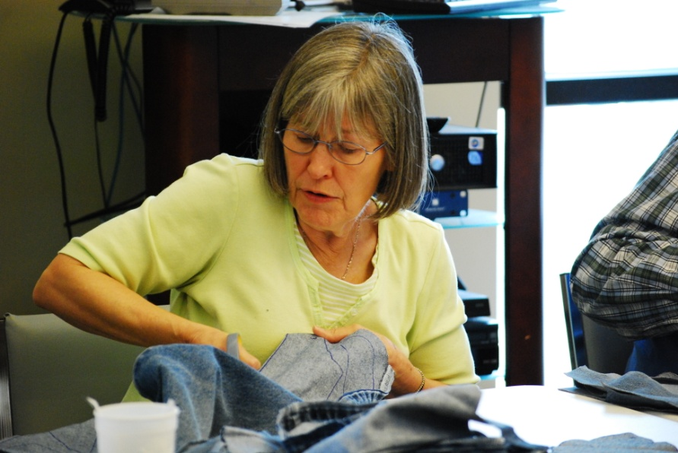
A Liturgy to Celebrate! Being of Christian Service
Week Seven of 2016 Christian Education Season
September 18, 2016
Missy Rose (extras-Elinor Brown)
Preparation for the Sunday:
- Locate a copy of the song “Celebration” by Kool and the Gang to play as a gathering song for worship each Sunday of the CE Season. You may not want to play the entire song since it is about four minutes long and repeats.
- Ask your worship committee or a creative bunch of folks to decorate the worship area with items that represent service. You may want to pile your altar high with canned goods from your food bank, prayer shawls from your prayer shawl ministry, blankets for a homeless shelter, etc. Also create a triptych collage by covering 3 pieces of poster board with pictures taken on various mission trips or pictures from our mission fields (For more information, ask a Mission Ministry Team staff member). Enlarge pictures on regular paper so people in the congregation can see them. Then create three stencils: one reading “Act Justly,” one reading “Love Mercy,” and one reading “Walk Humbly.” Using the stencil, spray paint these words on the collages. If you can’t make a stencil, have someone write these words clearly on each collage. Arrange them in the order above so they read as Micah intended! (Idea adapted from the book Come and See by Dean R. Heetderks, p.36).
- Look through the Additional Activities at the end of this liturgy and decide which of them you will do. Make plans to do them and gather materials as needed. You will also need to publicize and recruit people to help you with them so leave plenty of time to do so.
Call to Worship
One: Make a joyful noise to the Lord, all the earth.
Worship the Lord with gladness;
Come into God’s presence with singing.
All: For God’s love is everlasting.
God’s power to create anew is boundless.
One: Know that the LORD is God.
It is God who creates and claims us.
All: We are all God’s people,
the beloved sheep of God’s pasture.
One: The LORD is good.
The steadfast love and faithfulness of our creator endures forever.
All: Let us join with the chorus of all creation
in singing the praises of the LORD our God.

Call to Confession
We are called to respond in faith to God’s unending love and mercy. Jesus challenged his followers to care for the hungry, thirsty, naked, sick and imprisoned. We forget that Christ is found in these, our brothers and sisters in need. To ignore them is to betray Christ. We have much to confess. Let us take a moment in silent confession.
(Silent Confession)
Prayer of Confession (unison)
O God, we confess that we often fail to work toward justice when we hear the cries of the oppressed. We have failed to show kindness to those who carry heavy burdens. How often we strive for success in this world rather than walk humbly with you toward a new creation. Lead us by your Spirit to see the world from your perspective. Redeem us to see with your eyes, hear with your ears, and walk in your ways. Amen.
Assurance of Pardon
God is merciful, kind, loving and just. The kingdom of God is bursting forth in our midst. In Christ, our redemption is secure. Our cup overflows with the newness of life. Let us rejoice and respond in faith, trust and service. Friends, hear the good news. In Jesus Christ, we are forgiven!
Children’s Message
Read the book A Rose for Abby by Donna Guthrie. If you do not own this book, this is a great opportunity to buy it for yourself or for your church’s nursery or library. After reading it, you may want to make the following points:
- Today we are talking about people who see things that need to be done and then do them even if they have to leave their home to do so. Sometimes they only need to look out their windows to see what needs to be done. Doing things for others is called service; we are celebrating Christians who serve others because they love God.
- In this story, Abby looks out the window of her home which was next door to the church since her dad was the preacher. She saw a poor woman who was looking through the trash cans trying to find stuff she needed. Abby wanted to help her but didn’t know how, so she asked her dad if the church could help. Her dad said that the church was poor too. But that answer didn’t stop Abby from thinking.
- She thought about the lost and found box that had some gloves in it, so she took a paper bag, drew a rose on it, put the gloves in it, and then put the bag in the trashcan for the woman to find. And the woman did find it and was happy about the gloves because it was cold. Abby did this everyday with something different from the lost and found box. She also told her father that she knew the neighbors also had something to give. So they went to the neighbors to collect day old food, bowls and even found someone to cook soup for the street people. After the neighbors and the church served the crowd, Abby found a red paper rose placed in one the bags she had given the woman.
- Abby, a little girl, had a heart for service: which means that she felt the need to do good things for others. She shows us that we can all do something for other people to help them. And in the process, we are being a good example to other people, helping them to want to serve others too, which is what God wants us to do.
- Then pray something like this: God, we thank you for people like Abby who show us how important it is to serve others. Thank you for the people in the world who serve others and for the people in this church who serve others. Help us to be like them and like Jesus. Amen.

Prayer for Illumination
Lord, we seek to be transformed by your word. May your Holy Spirit guide us in the truth of your love and power. Open our ears, to hear your voice, our minds to understand your will and our hearts to trust in your love, so that we may serve you by serving others. We pray in Jesus name, Amen.
Scripture Possibilities for the Sermon
- Psalm 113—All servants of the Lord praise God because God meets the needs of the poor and needy.
This scripture provides an opportunity for the pastor to talk about the fact that as servants of God we are to help those who are in need, those who are poor. We are to raise them up.
This day is a time for all of the church to celebrate those who are involved with Christian service. We often help people raise funds to go on a mission trip, but do not always allow them to share the experience they have had and how it affected their faith journey. Be sure to take advantage of this time.
- Micah 6:1-8
- Psalm 100
- Matthew 25:31-46
- Galatians 5:1, 13-25
Prayer of Intercession
Creator God, it was your word that first broke through the darkness of chaos to bring forth light. You commanded the human race to be co-creators with you, by serving and tending your creation and all that is in it. By our failure, creation suffers, your beloved are marginalized by injustice, and your children go hungry. In you Lord, we find hope. You still brood over the chaos of this world and speak light into the darkness. We pray for those who hear your word and reflect your light in service and love.
We pray for Sunday school teachers, youth workers and all those who sacrifice their time and energy to teach and guide children in following the way of Christ.
We pray for missionaries who travel great distances to serve you by serving others. May they reflect your love, justice and peace to those who are in need.
We pray for those who serve the needs of the “invisible” in our own communities. Bless all who “see” with your love and respond in service: those who visit the sick and care for the infirm; those who serve our brothers and sisters who have no place to call home. We pray for the hands that prepare food for the hungry and arms that embrace the lonely and forgotten. Bless those who overcome fear with love and serve to transform the world.
We pray for those in our midst who serve you in all the ways we never see. Whether they clothe the naked, visit those in prison or clean the church, may they be blessed in your service.
We pray for your spirit to be with all who dedicate their lives to your service. May your light continue to break through the darkness and overcome the chaos of hate, fear and injustice.
Let us pray the prayer Jesus taught his disciples to pray…
Our Father, who art in heaven,
Hallowed be thy Name.
Thy kingdom come.
Thy will be done,
On earth as it is in heaven.
Give us this day our daily bread.
And forgive us our debts,
As we forgive our debtors.
And lead us not into temptation,
But deliver us from evil.
For thine is the kingdom,
and the power, and the glory,
forever. Amen.

If you intend to commission some of your service activities, you may want to do it here.

Invitation to the Offering
God is not interested in our burnt-offerings of empty gratitude. God requires our devotion and a commitment to action. Our offering here is just a beginning of the work of justice, the commitment to love, and the humble walk to which we are invited. Let us give in trust and love.
Prayer of Thanksgiving
We stand in awe of your presence, O God. As you are present to us here and now, you are present to those who serve you with their hands and hearts. May our gifts serve you in this ministry of presence. Bless this offering, Lord, to serve your purposes in the redemption of all creation. Amen.
Charge
One: Our relationship with God is secure and made whole in Christ Jesus.
And what does the Lord require of us?
All: We are called to respond in faith;
to do justice, to love kindness and to walk humbly with our God.
One: God moves all of creation from death to life.
God invites us into this work of redemption.
All: We rejoice in Christ’s love for us and his power to defeat death.
We have faith in the promises of God.
One: God does not send us out into the world alone.
The Holy Spirit is our guide and comforter
as we work to carry the good news to those who sit in darkness.
All: We go forth from this place to share the fruits of the Holy Spirit.
We rejoice in God’s love and are eager to share this love in faithful service. Amen.

Benediction
May the love of God, the peace of Christ and the power of the Holy Spirit be with you, as you share Christ’s light with this world. Go in peace. Amen.

Additional Activities
Hope for the World Prayer Wall—Put a blue plastic table cloth on the wall in your church (long-wise horizontal). Then use a projector and a transparency of a flat map to draw a map onto the table cloth. Ask people to use the sticky notes and pens provided to write a note of hope for particular parts of the world (a country or region) and put the prayer on that area of the map. Leave this prayer wall up for several weeks to give people a chance to read the prayers and offer their own prayers for both the writer and the situation.
Leave a Piece of Your Church—Have a group from your church gather to discuss having something for mission workers from your church to give to someone on the mission field. It may be a coffee cup with your church’s logo on it or a handcrafted item that one of your members has made. Consider its size and weight, which is usually an issue when packing for a trip. Have the church member giving the gift to take a picture with the recipient and post it somewhere special at the church.
Commission Your Servants—Have the pastor set up a regular time in a worship service to commission those who are going to be working in Christian service. These people may include those who work regularly in a soup kitchen, a homeless shelter, a mission trip, as a volunteer at a local hospital, a teacher, etc. Broaden the church’s idea of what it means to be a Christian servant. You might be surprised at those who are serving and those who would like to serve given the chance.

