Step Out
Called to Tell – Sent to Share
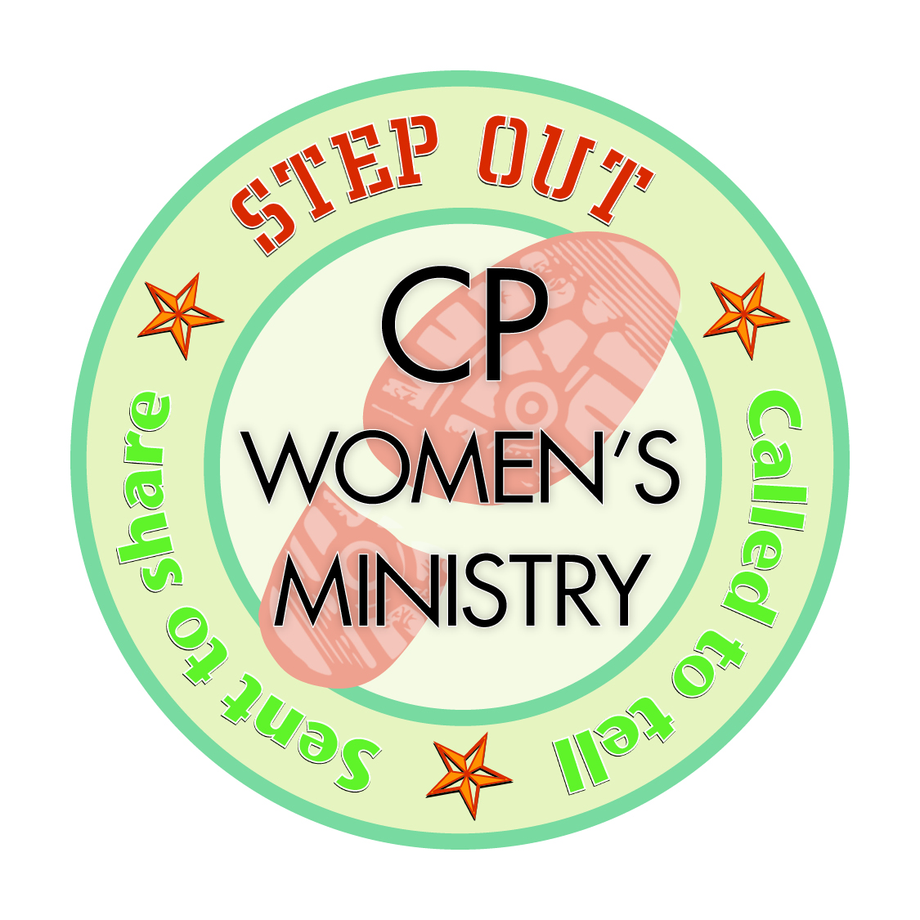
How beautiful are the feet of those who preach the Good News! Romans 10:15

Welcome to the new 2014-2015 Women’s Ministry Bible Study. This year you will “hear the voices” of six different women who will explore the theme – Step Out. Each one brings their own unique insight and perspective to a wide variety of scripture texts and themes. We hope that these studies will stimulate discussion, but more importantly, they motivate us to be messengers of God’s grace and love – both in words and deeds.

THANKS!
Gloria Diaz is an ordained Cumberland Presbyterian minister and member of Trinity Presbytery. She currently serves as Assistant Director/Bilingual Specialist at New Day in Christ Ministries, which is a ministry for men and women in jails and prisons around the country, as well as day-laborers in Houston, Texas. She was a member of Manizales CPC in Colombia, SA growing up and very active in the church and women’s ministry. Her involvement and commitment with women’s ministry has continued through her whole life. Gloria lives in Houston with her husband, the Reverend Fredy Diaz and son, Benjamin. You can contact Gloria at New Day in Christ Ministries, 2119 Avalon Place, Houston, TX 77019; (713) 527-7159, or at gloria@newdayinchrist.org.

Joy Wallace is a member of Faith Cumberland Presbyterian Church in America, where she wears many hats – elder/trustee, church treasurer, Sunday school teacher, choir member, sponsor of younger adult ministries, and provides oversight to media ministry, drama ministry and the girls’ ministry. She is also the current Stated Clerk of Brazos River Presbytery. In addition to her ministries in the local church and presbytery, Joy has provided national leadership to the CPCA on many occasions. Joy is a small business consultant and formerly president & CEO of J.O.Y. Foods, Inc. She is a native of Dallas, TX and did undergraduate work at the University of Chicago where she majored in Economics. You may contact Joy at jwallace@wlgllc.net.

Melody Dierking is a member of the Marshall CP Church, in Marshall, MO and the past president of the CP Women’s Ministry.

Sally Sain is a member of the Petersburg CP Church, in Fayetteville, TN and the current president of the CP Women’s Ministry.

JoAnn Shugert is a member of St. John CP Church in Arlington, TX and served as Convention Coordinator for 6 six years.

Cornelia Swain is a member of Faith CP Church in Bartlett, TN and was the director of Cumberland Presbyterian Women from 1975-2002.

