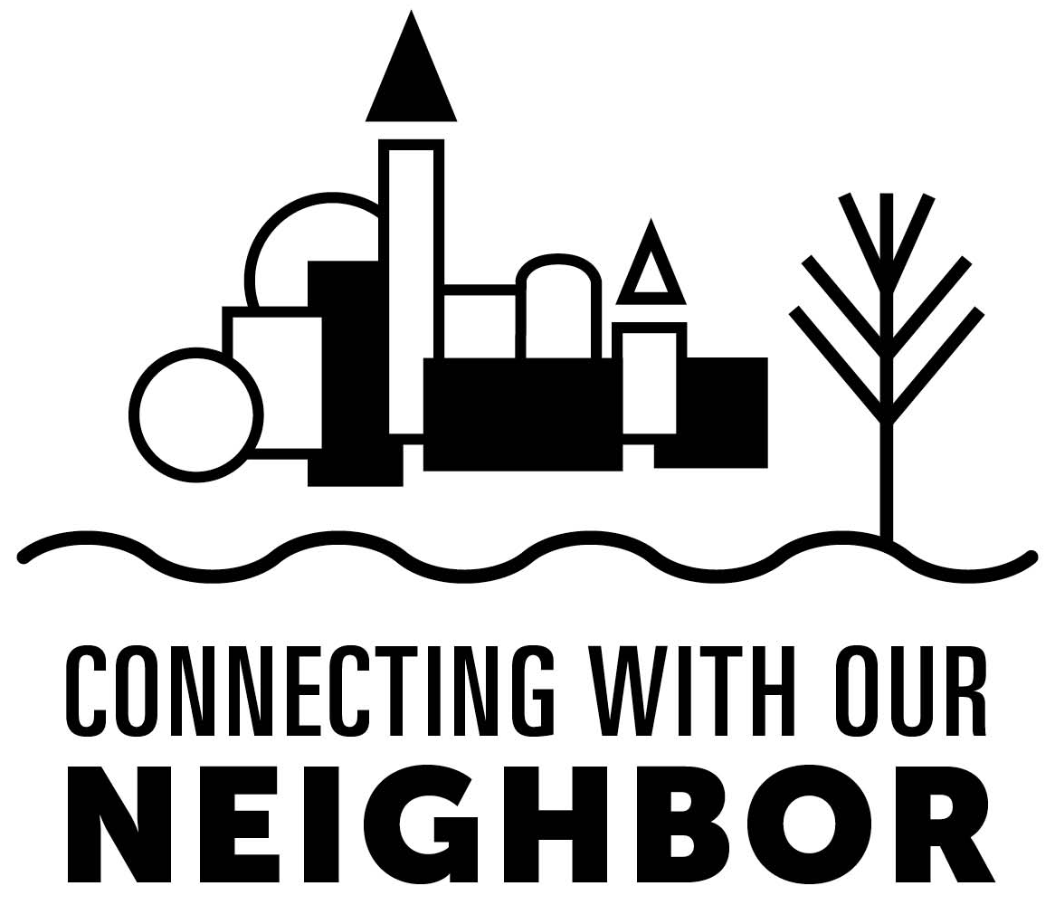

Welcome Neighbor! This coming year you will have the opportunity to meet 14 different neighbors that you probably bump up against every day. You will hear their stories. You will hear God’s words as it relates to each neighbor. And hopefully through the reflection questions and the action steps, you will find a way to be a neighbor to each one.

Thank you to the writers who shared their stories –

- Tracy Clark – Mentally Ill
- Nimisha Clawson – Different Faith
- Lisa Cook – Homeless
- Erin Daza – Immigrant
- Gloria Diaz – Prisoner
- Debbie Garrett – Abandoned or Foster Child
- Joy Graham – Unbeliever/Unchurched
- Daniel Hopkins – Addiction
- Joyce Merritt – in Crisis
- Lisa Oliver – Terminally Ill
- Judith Seva – Single Parent
- Diann White – Cross-Culture
- RheAnn WhitePeacock – Domestic Abuse
- Robin Wills – Bully

Many of the writers were willing to be open and vulnerable with their stories, and it is our hope that you will treat each neighbor’s story with love and compassion. Learn from them. Hurt with them. Rejoice with them. That is what neighbors do!

A big thank you to Pat White (North Central Region) who helped with proofreading and editing all of these stories to make them a unified resource. Her skill and work resulted in a great resource for your group this coming year.

As you meet these neighbors in the coming year, may you hear Jesus’ words to you; words that he spoke to the expert in the law in Luke 10:25-37 – “then go and do likewise. “(37) May you also “go and do likewise” this year.

