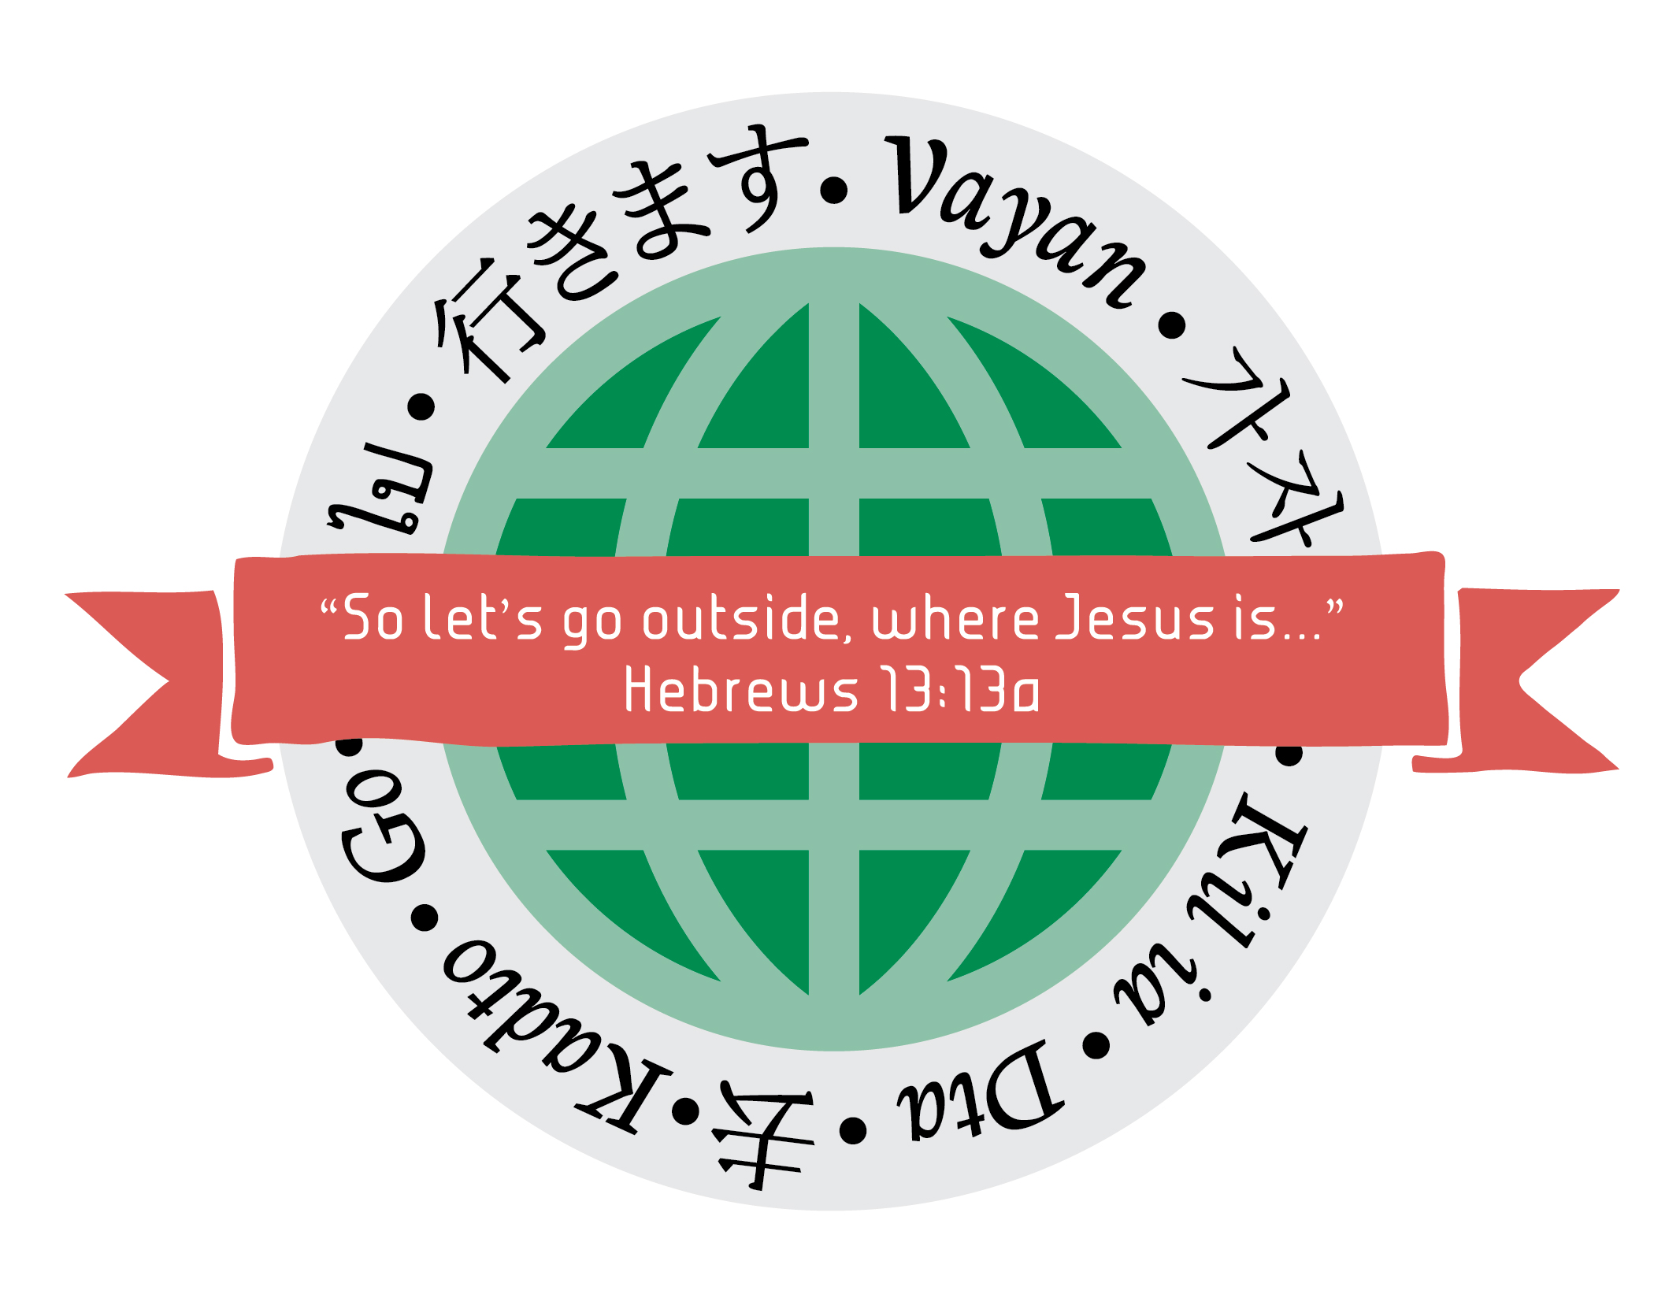
Membership Endowment Presentation
CP Women’s Ministry Convention, 2016
Nashville, TN
The year was 1924, the average yearly income was $2,196 which averages to about $42 a day. A new car cost $265, and the cost of a new home was $7,720. A gallon of gas was $.11 and bread $.09. Milk cost $.54 and eggs were $.48.
In 1924 a woman by the name of Eva Hughes had a heart for the mission field. Now while none of us here today can say we know her personally, I think we can relate to her passion to further the kingdom. Ms. Hughes heard the great commission and responded by starting a fund with $30 to begin what we now know as the Endowment Membership. Now, to put that $30 into perspective for you, in 1924, $30 was almost what the average person made in one week. For Eva, $30 was a lot of money, but I don’t think she saw it as how much she would do without if she gave up that $30, but how much she could help someone else. Her focus was on the Kingdom, building support for other ministers, missionaries, and ministries to come. I wonder what she would say if she could see how much her $30 has grown.
In the past 92 years, countless lives have been changed and affected due to her humble gift and obedience, and in 92 years her willingness to submit to God’s call to give has grown, I’m sure, beyond her wildest dreams. Thru December 31, 2015 the Perpetual Membership Endowment has reached $1,006,161 and has distributed $50,685 to various mission projects and sites around the world. The Patron Membership Endowment has grown to $810,401 and has distributed $40,687 to various mission projects around the world.
Those who have received these memberships are people we honor for following the footsteps of people like Eva Hughes. People who have a desire to see God do mighty work thru His children. People who have a desire to share the gospel and share Christ’s love to all the earth.
At this time, let us recognize those who have received these blessed memberships.
I would like to ask all who have a Perpetual Membership to please stand.
Are there any Perpetual Memberships to be presented at this time?
Please stand if you have a Patron Membership.
Are there any Patron Memberships to be presented at this time?
Please stand if you have a Diamond Perpetual Membership.
Are there any Diamond Perpetual Membership to be presented at this time?
Please stand if you have a Silver Patron Membership.
Are there any Silver Patron Membership to be presented at this time?
Please stand if you have a Golden Patron Membership.
Are there any Golden Patron Membership to be presented at this time?

Presented by Susan Gray, Murfreesboro Region

