**Set Them Free**

**Working Together to End Modern-day Slavery**

*Presentation at CP Women’s Ministry Convention, June 2012*

**Leader:** In Luke’s gospel we read how Jesus went to the Temple one Sabbath day and stood up to read from the scroll of the prophet Isaiah. And this is what he read -

*“The Spirit of the Lord is upon me, because he has anointed me to bring good news to the poor. He has sent me to proclaim release to the captives and recovery of sight to the blind, to let the oppressed go free, to proclaim the year of the Lord’s favor.”*

Jesus went about setting people free from their oppression, their hurts, their illnesses, their sins. He set free those with leprosy. He sent free from death Jairius’ daughter and his good friend, Lazarus. He sent free blind Bartimaeus. He sent free his close friend Mary Magdalene, and the nameless woman at the well. When Jesus ascended into heaven, the Holy Spirit came to be with us – so that we, as the Body of Christ in the world, can continue in Jesus’ work of setting people free. Women’s Ministry begins a new multi-year focus called, Set Them Free – a campaign to join hands with countless people of faith around the world to end modern-day slavery. So – the officers want to introduce this new initiative to you today.

**Reader 1:** When she was about 7, **Isabel** was sold into domestic servitude to a wealthy Taiwanese family who later moved to California. She endured a childhood of constant work and beatings and was Set Free in her 20s.

**Reader 2:** Who doesn’t like a creamy, delicious bar of chocolate? Well, I want to introduce you to the 10 year-old boy (center) who picks the cocoa beans that go into some brands of chocolate bars sold around the world. His name is **Abdul** and he is a harvester on an Ivory Coast farm. When his mother died, a stranger brought him across the border to the chocolate farm. He is given a little food, the torn clothes on his back, and an occasional tip from the farmer. Abdul is a three-year veteran of the job. He has never tasted chocolate. He is one of about 200,000 other chocolate child slaves on the Ivory Coast of West Africa. Abdul and the other child slaves know nothing else. They don’t know what freedom is. Slavery in the cocoa fields of the Ivory Coast is normal. It’s routine. And it’s easy to find. Let’s Set Them Free!

**Reader 3:** Please meet **Mariano**, a migrant farm worker from Florida who escaped a year long forced labor life by climbing through a ventilation vent in a cargo van that he and 2 other slaves called “home.” Making only $200 a week, they were forced to pay for the sleeping van they used each night to the tune of $20 a week; a van with little ventilation and no toilet. He had to pay $50 a week for meals of rice and beans and the occasional piece of meat thrown in a couple of times a week. If he used the outside water hose to bathe, he was charged. Transportation was another charge, work clothes, charged. His entire paycheck went to the owners – and he was still in debt. Mariano was forced to work long hours in the fields seven days a week. He was physically abused if he did not meet his harvest quota per day or if he was sick and unable to work. His story is not unusual and is repeated over and over again from the fruit and vegetable fields across the United States, and we have to Set Them Free.

**Reader 4:** She’s called a “lot lizard.” A sexually exploited 16-year-old named **Meredith** is forced by her pimp to prostitute herself at truck stops along the nations interstate highways. She was sexually molested by her stepfather as a young child, and she figured that her mother would not believe her story. She was in and out of trouble in school. She had run away from home several times, only to be picked up, sent off to juvenile detention for 30 days, and returned home again. Eventually, she decided to run away for good. She wound up in North Carolina, going from truck driver to truck driver – using her body to make her pimp rich. It is a sad life, not one that she ever thought she’d be living. She is praying to be Set Free from her prison.

**Reader 5:** I would like for you to met **Kumar** from Nepal. He thought he was being recruited by a Jordanian company to work in the United States, but instead he was sent to Iraq, where he was forced to work on a military base against his will. His passport was confiscated and he was not Set Free until after spending four years in servitude.

**Reader 1:** I want to introduce you to **Martina,** a 19-year-old young woman who was trafficked to Italy under the pretenses of a better job working in a restaurant. Martina grew up in a troubled home with an abusive, alcoholic father and a sick mother. She was looking for a way out. One day, she thought she’d found that way out when she was offered a job in Italy. Once Martina arrived in Rome she was locked in an apartment for 2 months where she was repeatedly raped and beaten in order to “break her” will and turn her into a prostitute. We have to set the Martinas of the world Free!

**Reader 2:** Please meet **Theresa Flores**, a survivor of human trafficking. She was a bright and beautiful 15-year-old from a middle-class family who had just moved to an affluent suburb of Detroit. Her nightmare begin when she was tricked and blackmailed into sexual slavery by a young man from her high school whom she had a crush on. During her last years of high school Theresa was raped, blackmailed and forced into a prostitution ring. During her 2-year ordeal, Theresa’s middle-upper-class parents had no idea what their daughter was doing after school. Theresa now works to help Set Free other young girls who are sexually exploited through her work with SOAP – Save Our Adolescents from Prostitution.

**Reader 3:** Her name is **Mutesi** a woman from Rwanda who was trafficked to Seattle, Washington. In her own country, she worked for a wealthy family and it was a good relationship. The woman asked her to move to the U.S. and work for her relatives, who were from East Africa as well. At first Mutesi declined, not wanting to leave her children. Eventually, she consented. Her ordeal began immediately upon arrival in the U.S. She took care of a 2-year-old and a baby and all of the family’s meals – cooking, cleaning, gardening and more. She worked almost 100 hours a week. The couple paid her $70 a month and insisted that she talk to no one. She was eventually Set Free!

**Reader 4:** His name is **Jose** and he is from Chile. He is a vegetable picker from California and he is a slave. He deseparately needs to be Set Free.

**Reader 5: Sanju** grew up in Nepal with her parents and seven siblings. Her family was always in debt even though they worked hard and were industrious. Her father loaned her to a hotel where she worked for $3.50 per month. Little Sanju became sick and unable to work, so the hotel owner sent her home. A few months later, her father tried again, this time he sent her to Kathmandu with a labor broker to weave rugs hoping to receive $40 a month. She worked 16-hour days weaving rugs, then had to cook and clean for the broker and his wife. She was eventually discovered in her prison and Set Free.

**Reader 1:** When **Agnes** was 10, she was abducted from her family’s vegetable garden where she was working in Uganda by rebels from the Lord’s Resistance Army. When she was 11, she was forced to kill another child who had tried to escape. She said, “They told me if I do not kill that person, they will kill me.” When Agnes was 12, she was raped by one of the rebel commanders who took her as one of his “wives.” When she was 13, she managed to escape. With the help from a farmer, she fled to a nearby army barracks. A few weeks later she was Set Free and reunited with her sister.

**Reader 2: Francisco,** an 8-year-old boy from Haiti was trafficked into the Dominican Republic across an unofficial border which was essentially a dry creek bed. He was one of 2,000 children trafficked across the border in 2009 following the devastating earthquake. Once in the Dominican Republic he was sold to a wealthy family as a domestic slave. Will we set him free?

**Reader 3**: Meet Jessica, a prostituted child in Las Vegas.

**Reader 4:** meet 23 people who were freed from a brick kiln in Nepal. They are all from the same family.

**Reader 5:** meet a 5-year old girl from Rwanda who was sexually abuse and enslaved.

**Reader 1:** meet the 17 young women who were rescued in the Philippines from being sold commercially as sex slaves.

**Reader 2:** meet the 27 million people across the globe who are victims of human trafficking at any one time.

**Reader 3:** meet the 600,000 to 800,000 people who are trafficked across international borders worldwide every year.

**Reader 4:** meet the 300,000 to 400,000 CHILDREN who are trafficked across international borders worldwide every year.

**Reader 5:** meeting the women who number 80% of all those trafficked across international borders worldwide every year, mostly for sexual exploitation.

**Reader 1:**  meet the 50,000 trafficked people within the US, with 46% of them being trafficked as prostitutes.

**Reader 2:** meet God’s children who are crying out for help. We have to do what we can to set them free!

**Leader:**

Will we set them free?

Will we do what we can to learn what modern-slavery looks like?

Will we do what we can to advocate for change in our laws?

Will we do what we can to rescue innocent victims?

Will we do what we can to stop the perpetrators of these crimes?

Will we do what we can to set the oppressed free?

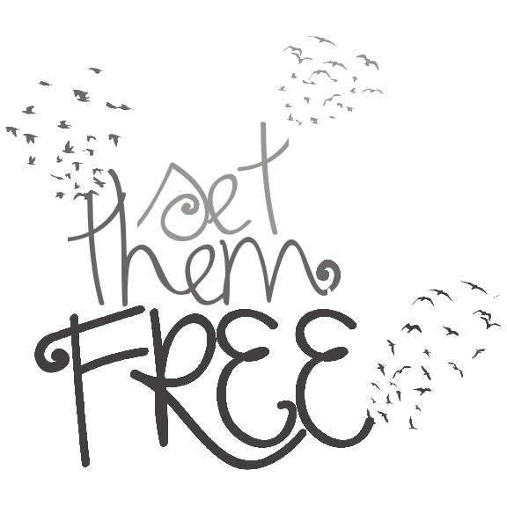

**All:** ***Yes we will! Yes, we will set them free! We will pray – we will learn – we will study – we will advocate – we will give our money – we will show love whenever and however we can to these innocent children of God. Yes – we will set them free!***