Send Me to Make Purple Cows
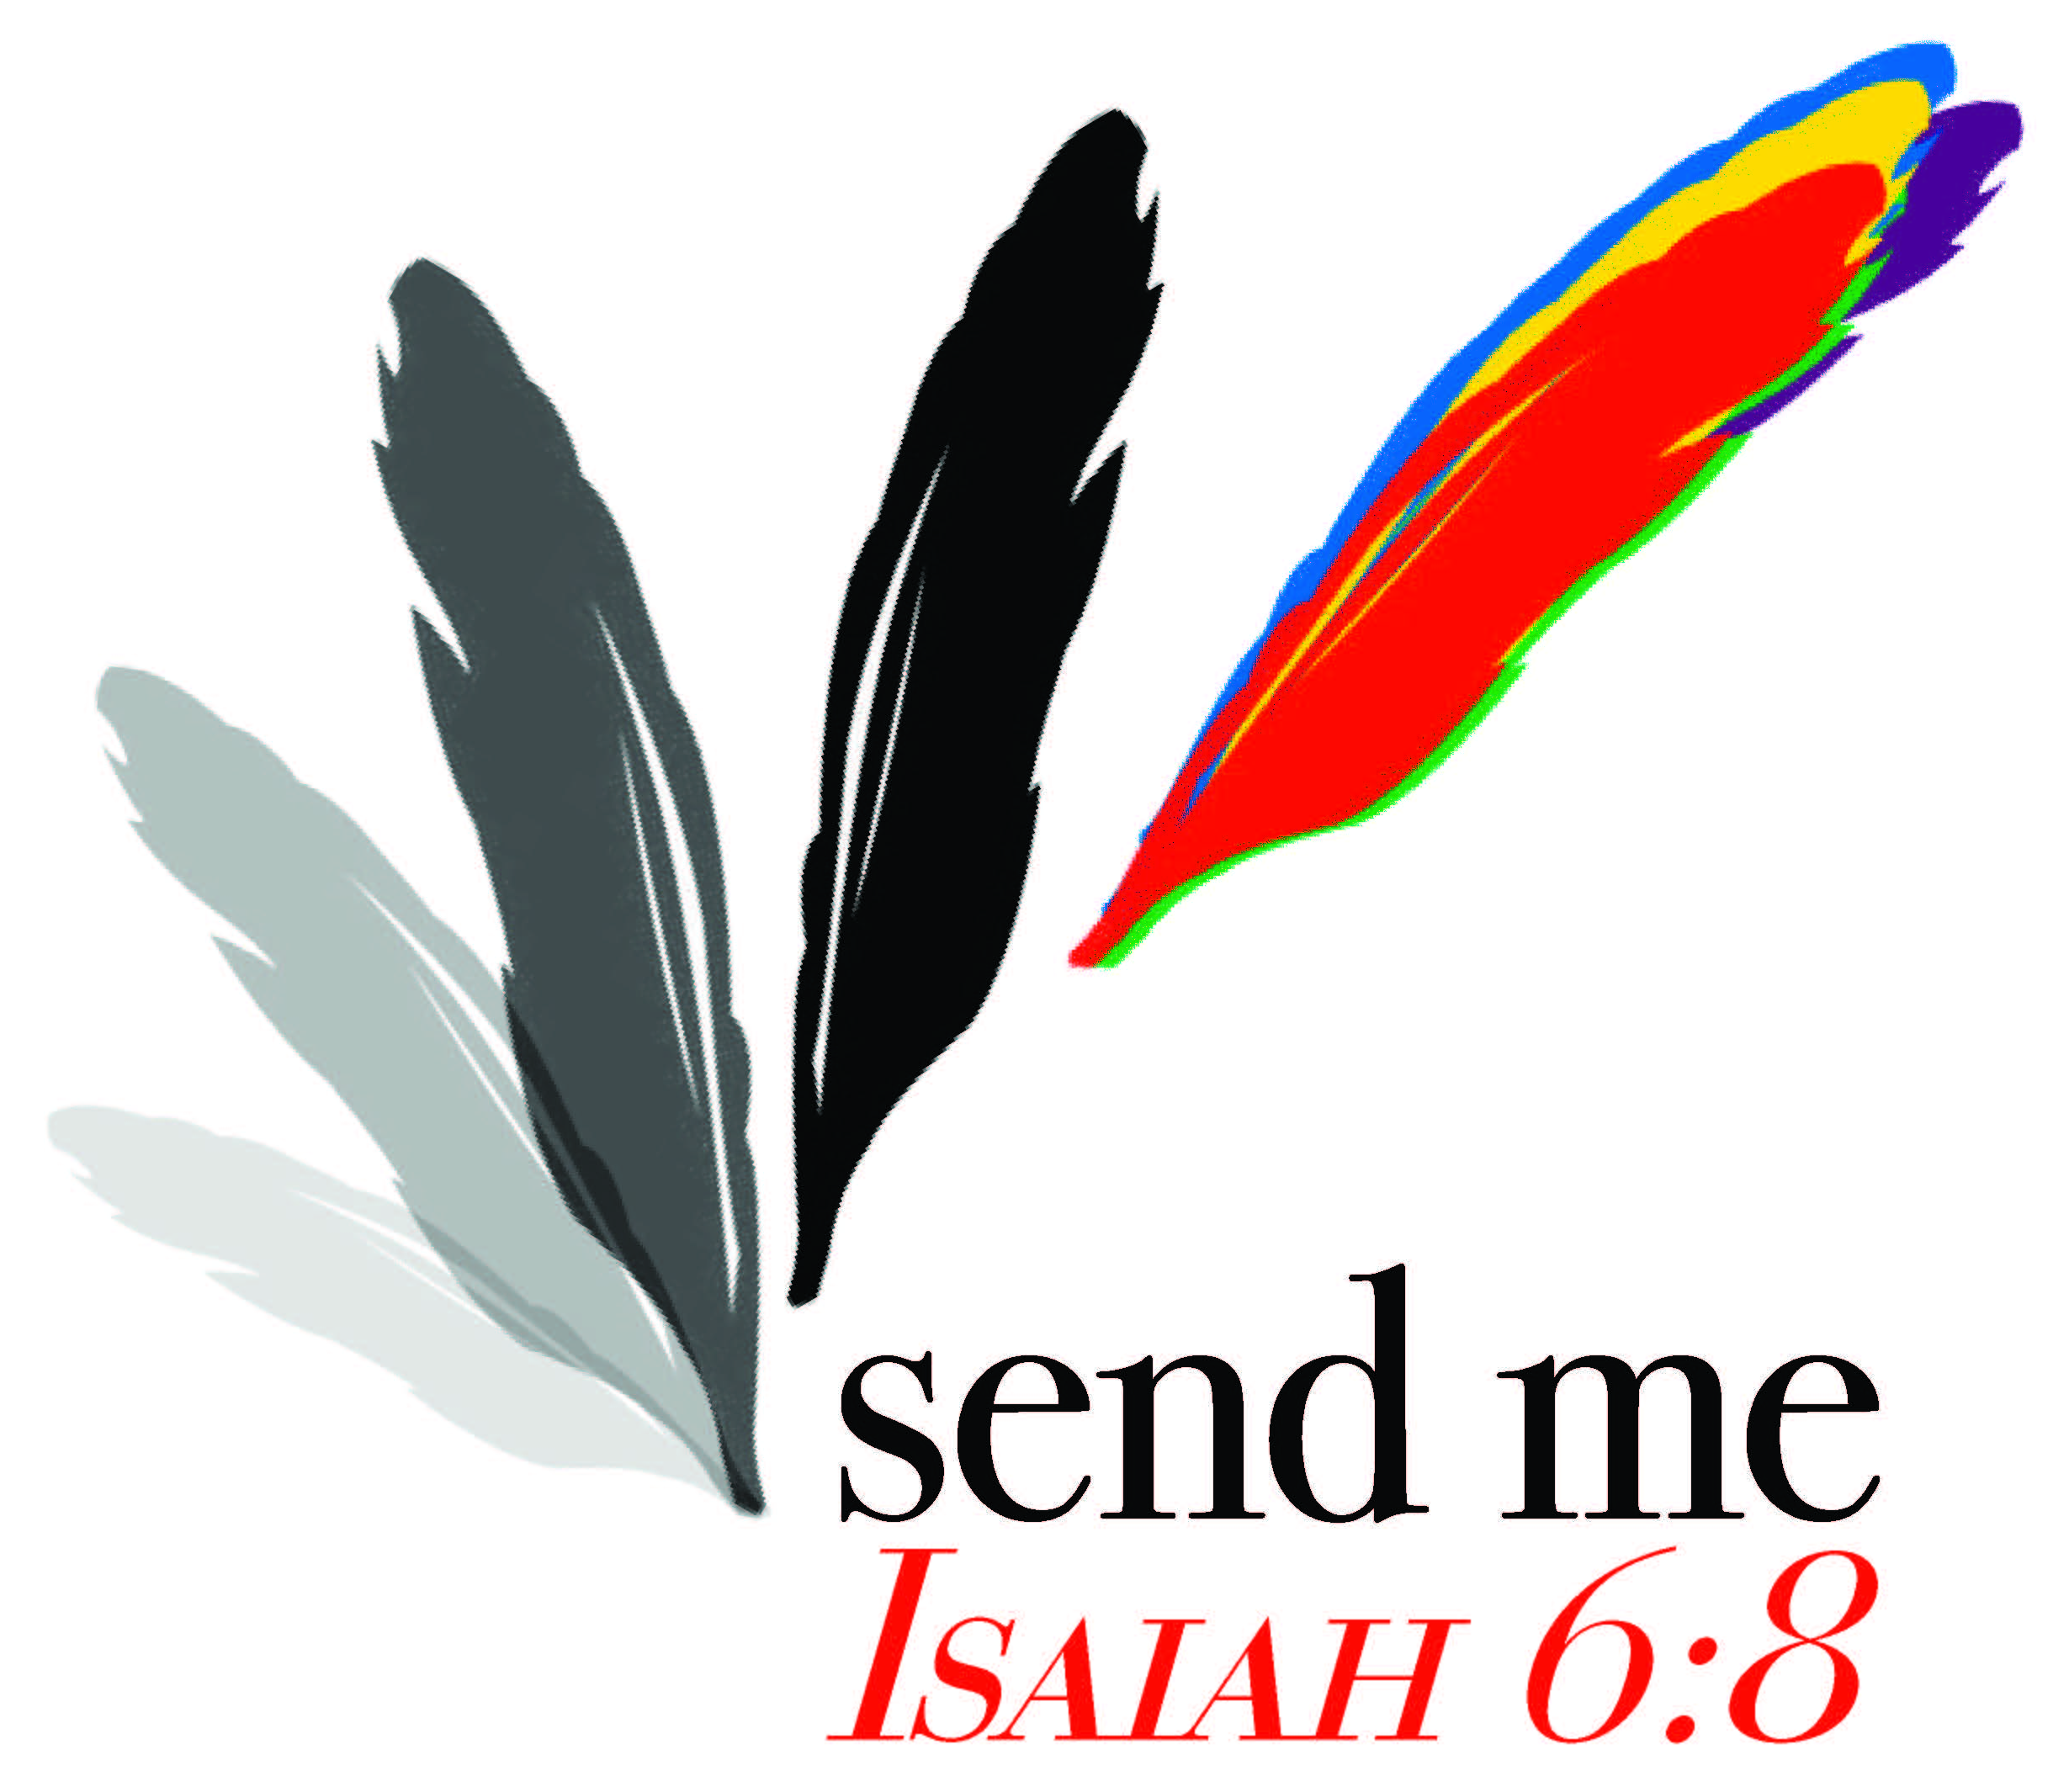
Rev. Pat Pickett

“But God can make a purple cow!” This was my defense of God which found me sitting in the corner, refusing to color my cow black with white spots. That was the beginning.
What do clay, glue, ink and Hebrew verbs have in common? In my first year of college we were asked to write down what we wanted to be when we grew up. My answer was, “an artist and a theologian.” My professor would not accept this answer. “Only ONE,” she said. Undaunted, I wrote “theoartist” and turned it in. How could I give up either one? I didn’t know how it would happen. I only knew that something deep inside answered for me.
In Divinity School, my focus was Hebrew Scripture. My mentor, and chair of my committee had the reputation for being the toughest professor on campus. It was time to write my dissertation and I approached him with my plans. “I am going to write a ballet for my dissertation.” He sat there in utter silence. Then, “You plan to do what?” “A ballet, sir.” What happened in the intervening months and years before my dissertation was finished is not suitable for print, but the Rochester Ballet performed my dissertation in Asbury First United Methodist church on the fourth Sunday of Lent, March1993 with an orchestra and 75-member choir.
My most incredible challenge was as chaplain for the individuals at Clover Bottom Developmental Center. Here I was with Hebrew, Greek, Aramaic and 80% of my parishioners could not talk. Color became the language of our prayer and it wasn’t long before I was carrying colored scarves to each visit asking, “What color is God for you today?” Thus began the most wonderful ministry of my life.
The Frist Center for The Visual Arts in Nashville announced an art contest for persons with disabilities. At the time I was also functioning as art therapist at Clover Bottom and had a studio where many of the individuals came at least once a week. We combined prayer and art in a delicious way. I told my supervisor that I wanted to enter some of the art that was done by our people. “You can’t be serious!” I was dead serious. I procured all the permissions and sent off slides from 15 persons. Little did I know that there would be over a 1,000 persons entering and only 50 accepted. It was to be juried, that meant no one knew where the entries originated. Then, the letter arrived. NINE from Clover Bottom out of fifty were chosen to be on display.
The closing of Clover Bottom was one of the darkest times of my life. What kept me alive during that time was my association with PAS (Program of Alternate Studies). This year will be my nineteenth year teaching Old Testament. Art and theology were a perfect marriage for this part of my journey. Always incorporating art in some way in every class gives students permission to think outside the box, to color outside the lines and to make purple cows if that is how they see God’s word working in the lives of the people they serve.
Currently, I am blessed to pastor a church that allows for coloring cows whatever color I think they need to be. We have an art outreach program, ART FROM THE MOUNT, for children who are unable to attend tuition based programs. Beginning with fifteen children two years ago, we registered 43 children this fall. I smiled when one of the children made a purple donkey for the Nativity Scene. You know that donkey had a place of honor.

Reflections

- God’s invitation to share in creativity is sprinkled throughout Hebrew and Christian Scriptures. Read Psalm 19:2, Gen. 2:7, Isaiah 40:28 and Job 12:10. You may wish to share other examples.
- Being “in” the act of creation, the Holy Spirit is moving then, now, and in the future. God is doing something and each of us is there in this moment. Living that creativity in our time is risking a new idea, a new song, a new movement toward justice – peace – ego appraisal without fear of failure. While the heavens reveal the glory of God and the sky tells of the work of God’s hands, where do you see the work of God’s hands in your life? How does creativity help you listen rather than talk?

Call to Action

- Creativity is freedom to risk failure. By discussing the following questions, what changes may occur in your lives? What kinds of dreams might be realized in my prayer life if I’m free from fear? Am I afraid to suggest new ways of doing things because I fear non-acceptance? Am I hampered by the fear of ridicule? Can I allow myself to fail so that I can reach new growth? What might this mean in my faith community? What would it cost me to challenge a way “we’ve always done things,” for the good of the church?
- List changes that might be made in your congregation although you have never done it that way before.

Prayer
Try prayer without words. Pour paint (yellow, blue, red) on a blank surface letting them merge. Within those three colors are all the colors. The PROCESSS of allowing patterns to emerge that might offer insights is where conversation happens. Listen to God and your own heart as yellow and red become orange, red and blue become purple, yellow and blue become green. Relax and be still. You are now in a mysterious and wonderful space, which sometimes is a struggle and other times is a celebration of your shared creativity with God. Are you willing to make mud pies with God?
(NOTE TO LEADER: the prayer experience will work beautifully as a Guided Meditation. Prepare the space and materials. When everyone is settled, invite them to take a couple of deep breaths and slowly exhale. Then say the above words – take pauses and allow for God’s Holy Spirit to work.)

