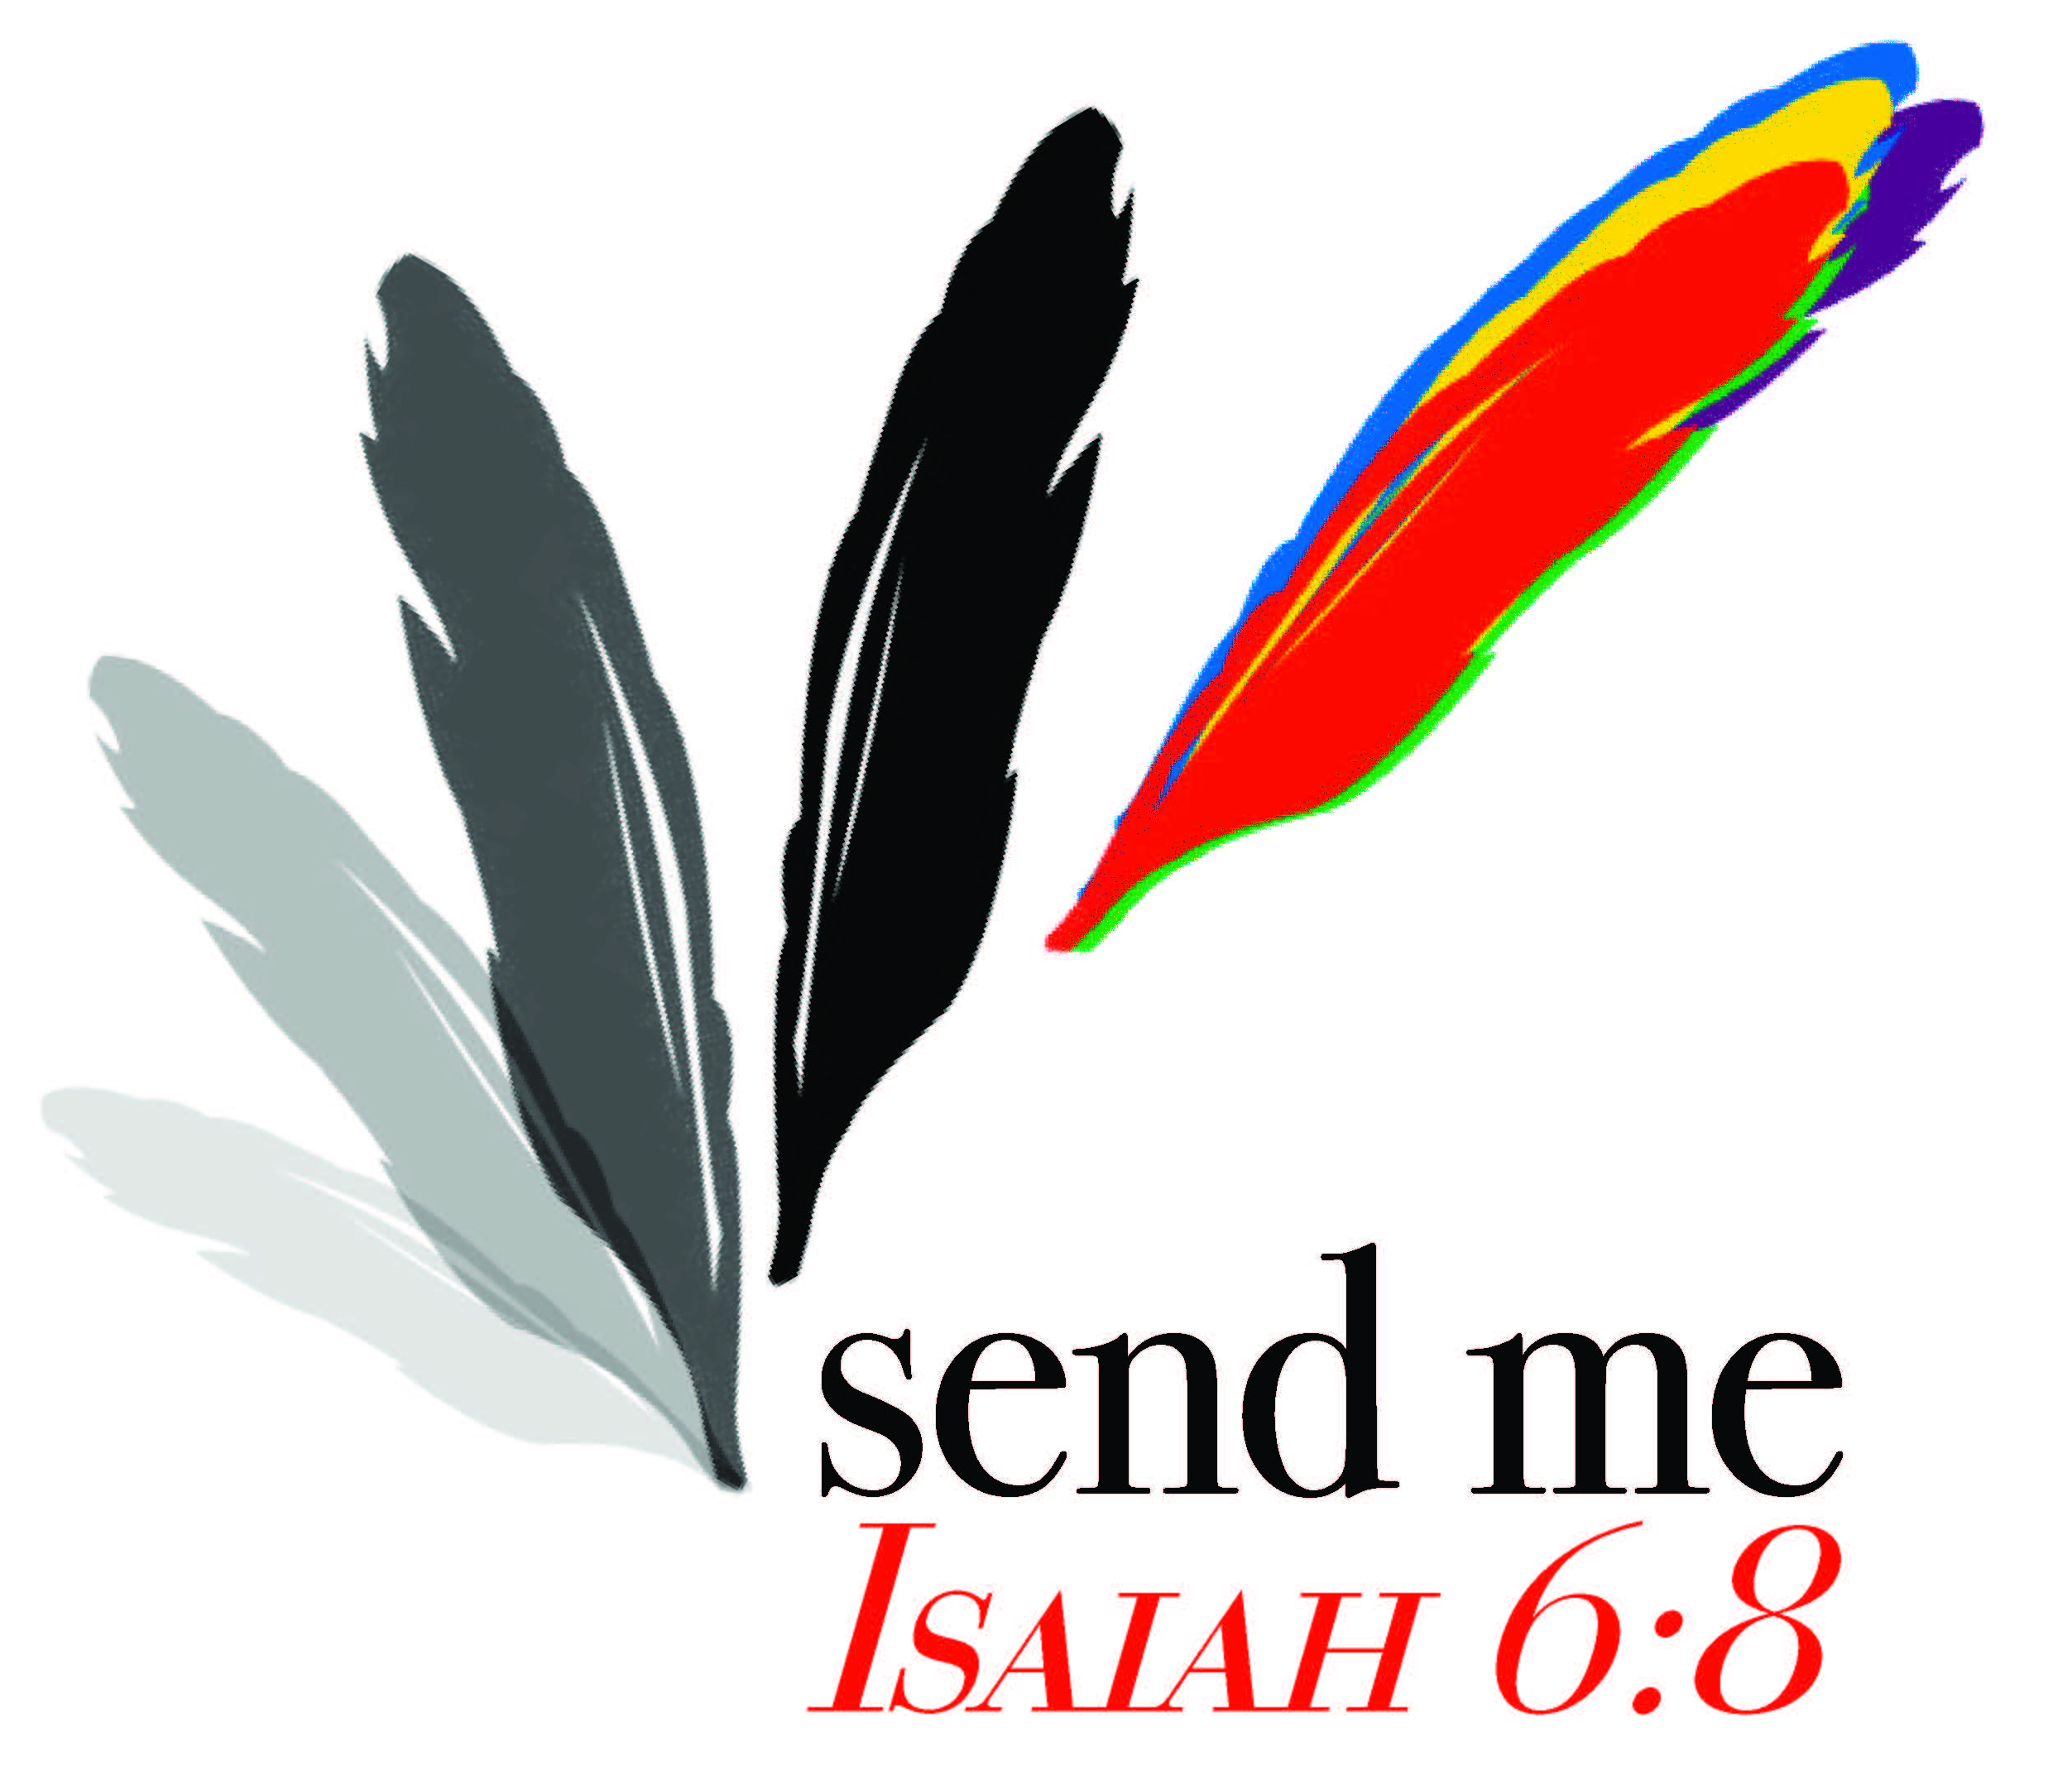
Get ready to hear some amazing stories from twelve women who answered God’s “call” to “GO!”. This year’s Bible study resource explores the theme “Send Me” based on the call of Isaiah in chapter 6 –

“Then I heard the voice of the Lord saying, “Whom shall I send, who will go for us?” And I said, “Here am I; send me!” (6:8)

From that point on, Isaiah was an outspoken messenger for God. Sometimes his message was received with an open, receptive heart. More times than not, though, it was met with resistance, obstinacy, and anger. Even though God called him in the midst of worship, the task was not an easy one.

That is what we will discover in these 12 call stories. You will get to know these women in ways that you’ve never known them before. You will hear of their struggles, doubts, fears, concerns and reluctance. You will also hear their heartfelt response to God, “Here am I, send me.”

Thank you to those women who shared their stories with us this year:
- Martha Chambers – Hands of Harvest Region, Arkansas Presbytery
- Luz Dary Guerrero – former missionary to Mexico, member of Andes Presbytery
- Kay Jang – missionary to the Philippines with her husband, Daniel
- Nadara Jones – Murfreesboro Region/Presbytery
- Sarah Lee – missionary to Southeast Asia with her husband, David, member of Tennessee/Georgia Presbytery
- Anay Ortega – former missionary to Guatemala, Andes Presbytery
- Socorro Pejendino – missionary to Guatemala with her husband Fhanor, member of Cauca Valley Presbytery
- Pat Pickett – pastor of Mt. Denson CPC, Nashville Presbytery
- Lindsey Sims – missionary to Salvador with her husband, Jacob, Brazil, Grace Presbytery
- Beth Wallace – former missionary to Colombia, who served alongside her husband for over 50 years. She continues to live and work in Cali, Colombia.
- Jessica Wilkerson – missionary to Colombia (Emaus Presbytery) with her husband, Patrick, Presbytery of East Tennessee
- “Sue” – missionary to an undisclosed country in Central Asia where she serves with her husband. They serve God in creative ways because the country is closed to Christian missionaries and the gospel.

A great BIG “Thank You” to Pat White, who served as editor of this year’s study. Her work serves to lift all of these stories from printed words to living testimonies. By utilizing her reflection questions and action steps, readers will be able to explore their own call stories as disciples of Jesus Christ. Pat lives in Fairfield, IL and is a member of North Central Region and is active in her church, region and community.

