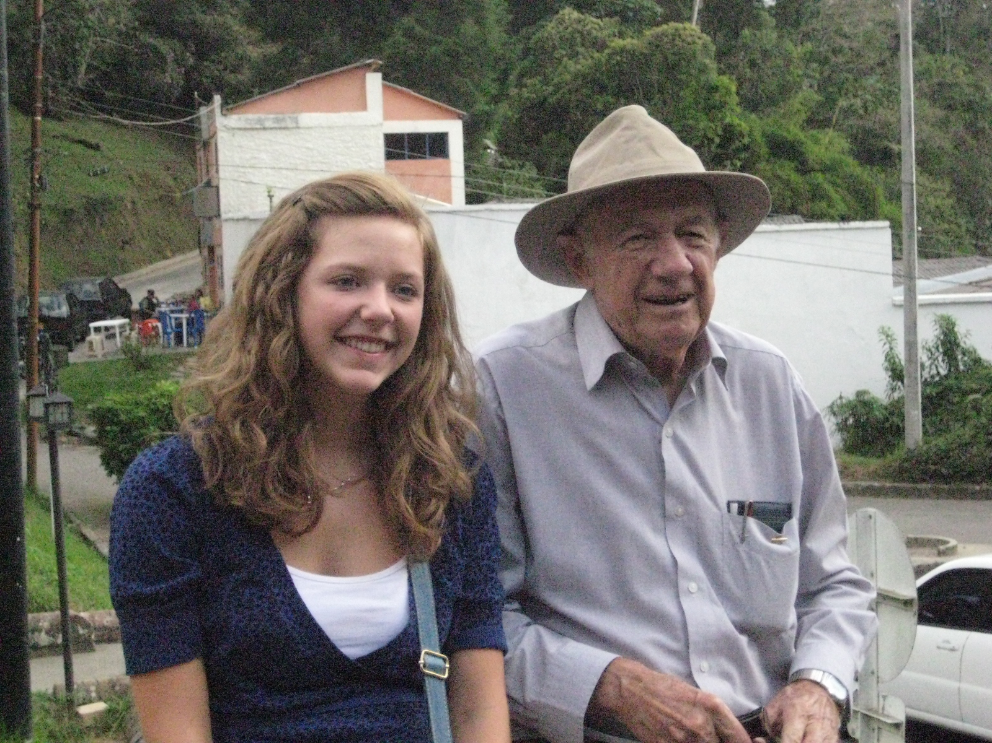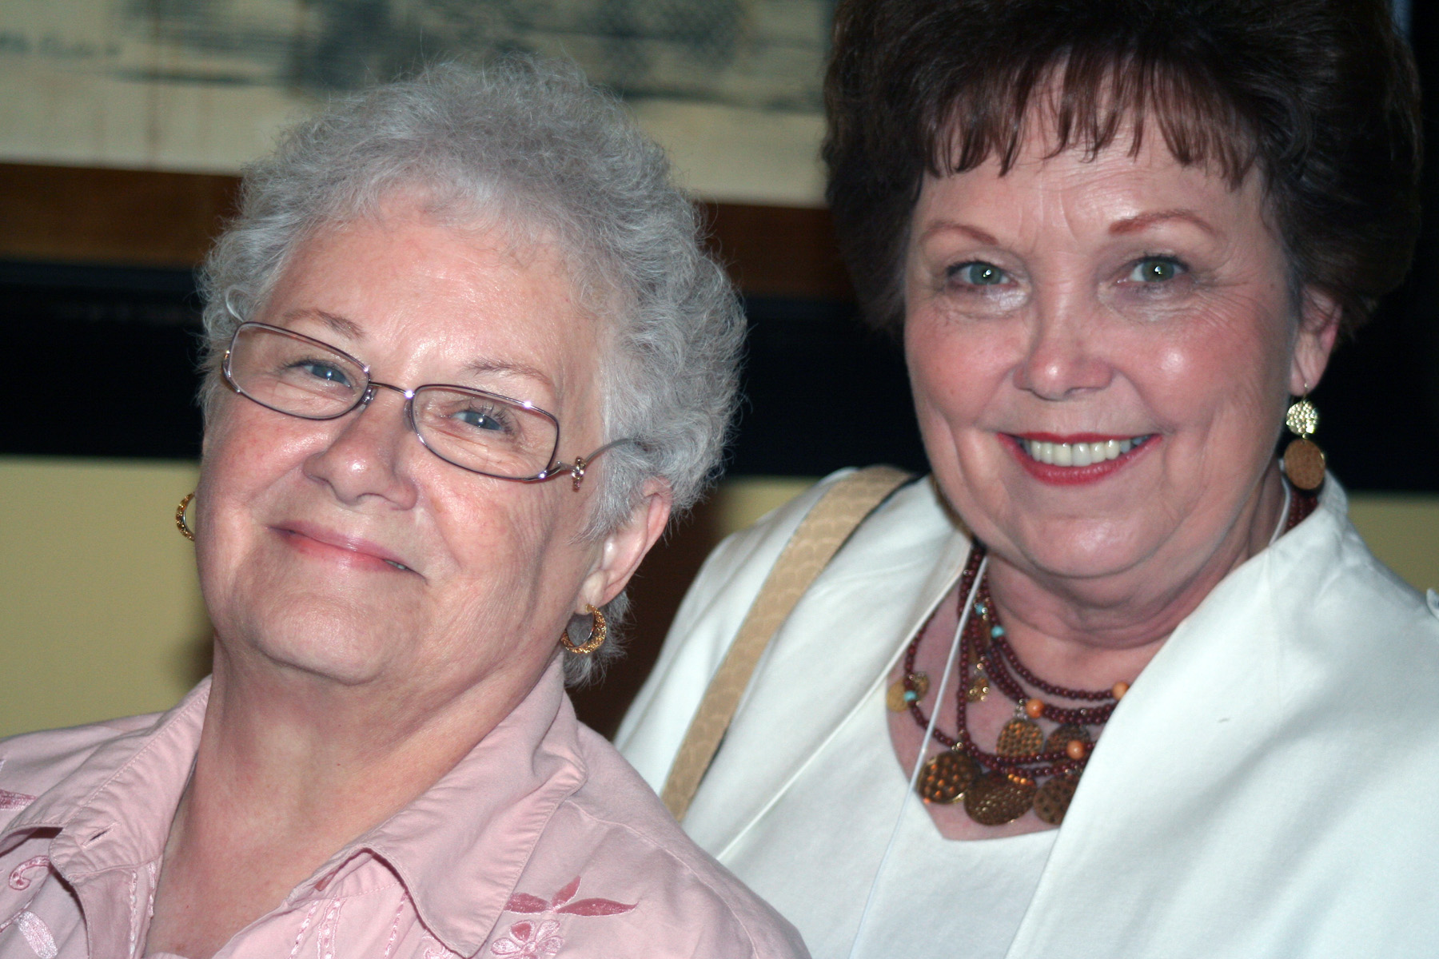

A Living Reality

8207 Traditional Place  
Cordova, TN 38016-7414  
901/276-4572, Ext. 203  
www.ministrycouncil.cumberland.org/womensministry

Missions Ministry Team

**Advantages of Membership Endowments**

Making a gift and seeing the results become a lasting reality.

Providing immediate income for the mission work of the CP Church.

Helping sustain the missions program in the years to come.

Requires only a small part of one’s accumulated possessions.

Recognizing a person’s ministry in the CPC.

Memberships for the Missions Ministry Team may be established by an individual, Women’s Ministry (local/region), or any other group or organization in the church, presbytery, synod or Convention. Memorial membership may also be bestowed. An application should be secured which includes the name of the recipient and the donor (s), the name and address of the person to whom the certificate is mailed, and the other necessary information. Mail the application along with a check to cover the amount of the membership to the Missions Ministry Team, 8207 Traditional Place, Cordova, TN 38016-7414. Allow three to four weeks to receive it.

**Membership**

**Endowment Program**

## How Is A Membership Given?

In 1924, Mrs. Eva Hughs of Missouri, a pioneer and courageous worker who had labored sacrificially for the cause of missions, became concerned that her life would soon be spent and she would no longer be able to serve. The banks were then paying 4% on “time deposits”. So she wrote the Board of Missions and asked where she might place $30.00 on a “time deposit” to assure that the accruing interest of $1.20 per year might perpetuate her dues, thus become A Living Reality!

**Why Give A Perpetual or Patron Membership?**

As in all endowment giving, people who are currently enjoying the peace of mind, the joy, and the economic tax advantage, are offered an opportunity to make a gift that will become A Living Reality. The money is placed in an endowment fund and only the income is used for the mission program of the CP Church.

Description of Members

* **Perpetual and Patron** – given to anyone who is concerned about strengthening and sustaining mission work.
* **Diamond Perpetual** – given to anyone who has served in the CP Church or women’s ministry faithfully for a period of 10 years or more.
* **Silver Patron** – given to a woman who has served the CP Church or women’s ministry faithfully for 25 years or more.
* **Golden Patron** – given to a woman who has served in the CP Church or women’s ministry faithfully for 50 years or more.

**Membership Types**

On payment of a specified amount of money by an individual or a group of individuals to the Membership Endowment Program, one may receive membership status and a certificate from the Missions Ministry Team. Each of the memberships can also be given in memory of someone. The types of memberships are:

* Perpetual - $30
* Diamond - $50
* Patron - $100
* Silver Patron - $125
* Golden Patron - $150

### Perpetual – Diamond Perpetual – Patron – Silver Patron – Golden Patron

# A Living Reality